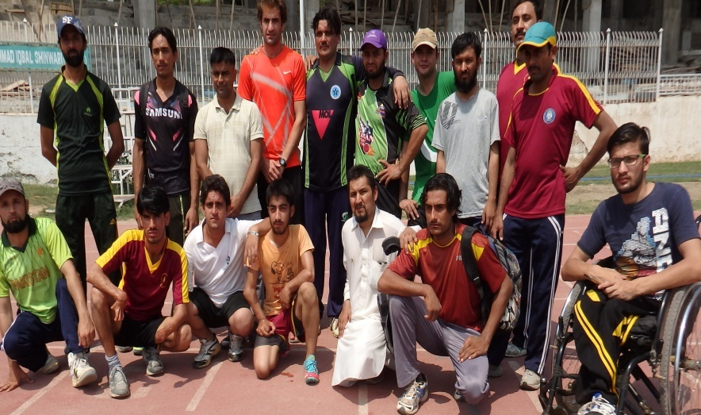
Annual General Report of SPDA (Special Persons Development Association)
(January to December 2016)

Special Persons Development Association (Reg) Peshawar KPK Pakistan
Prepared by: Mr,Javed Khan,Ms Mehar Un Nissa
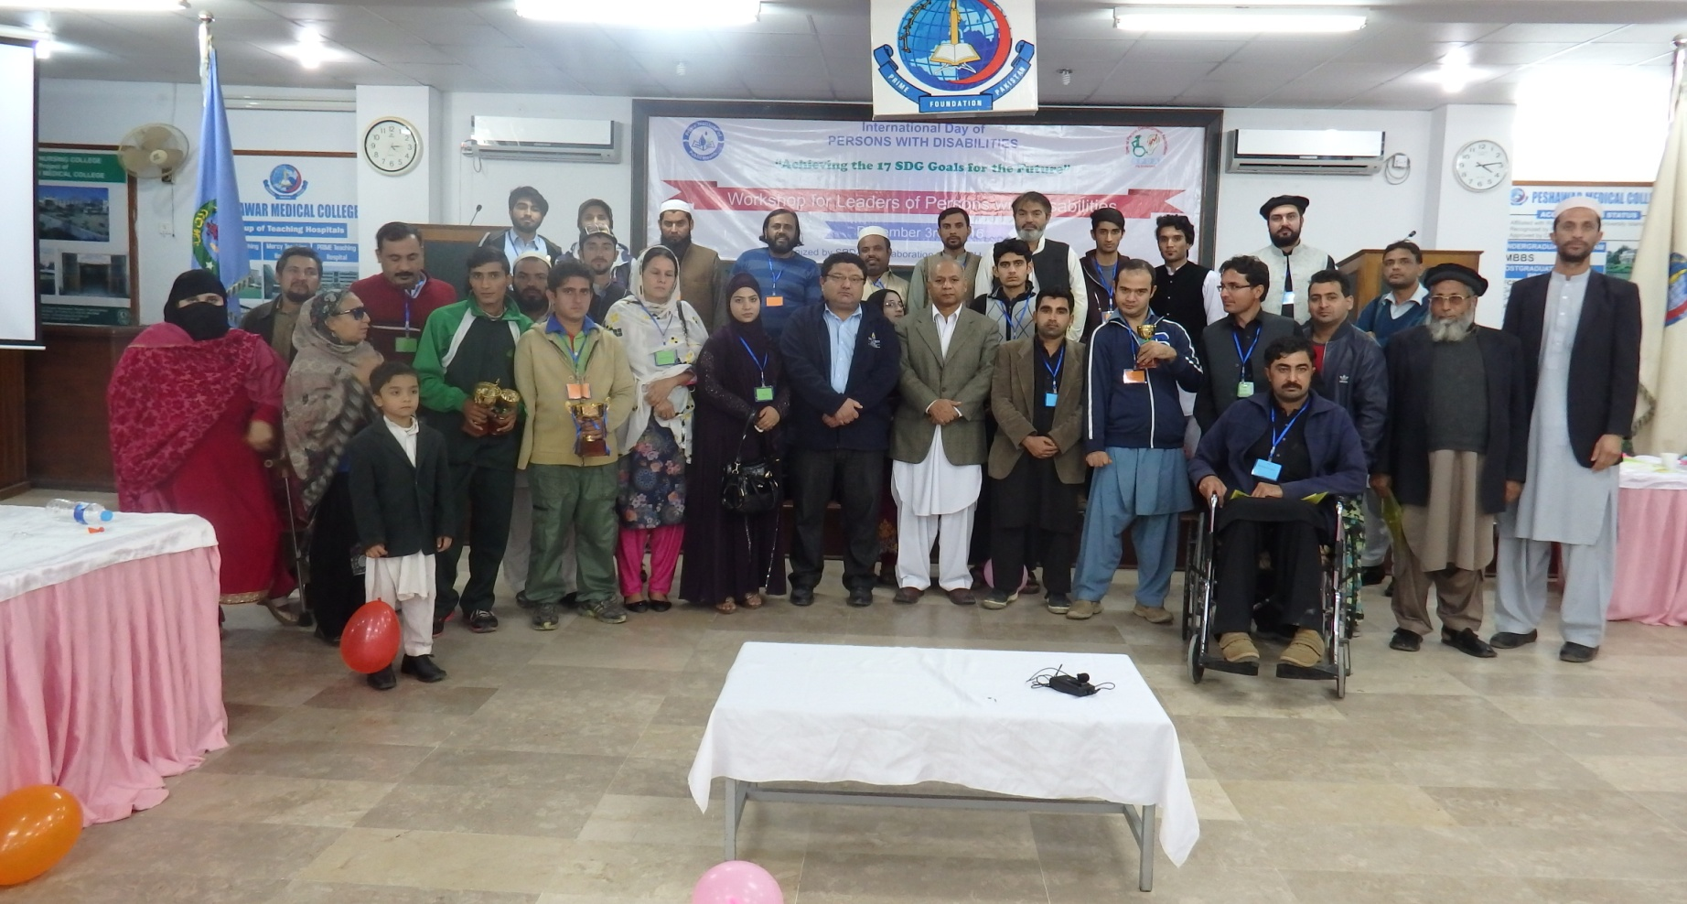
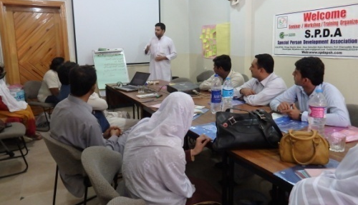
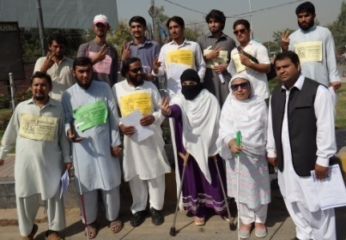
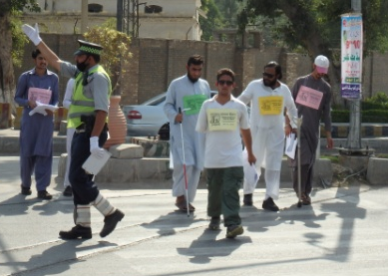
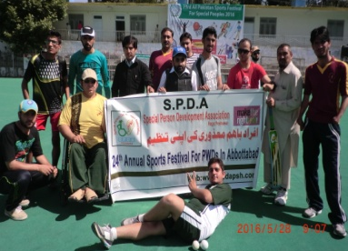
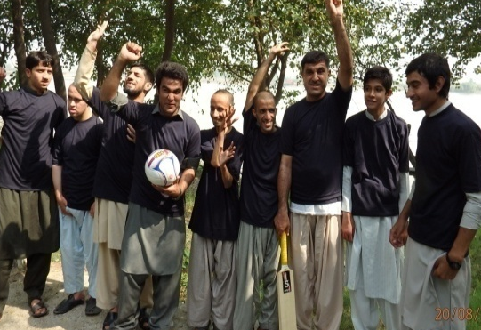
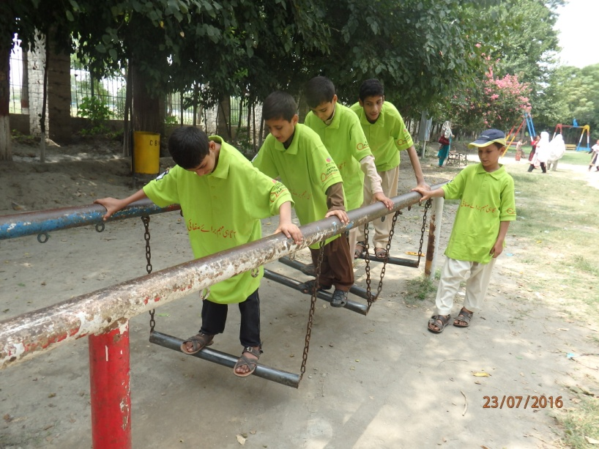
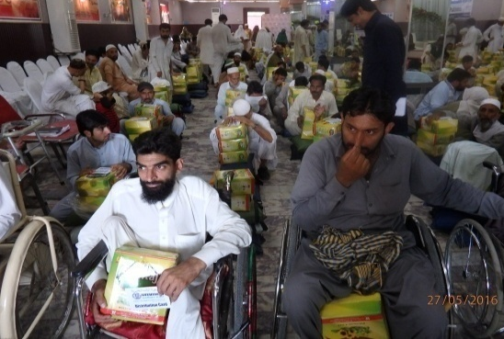
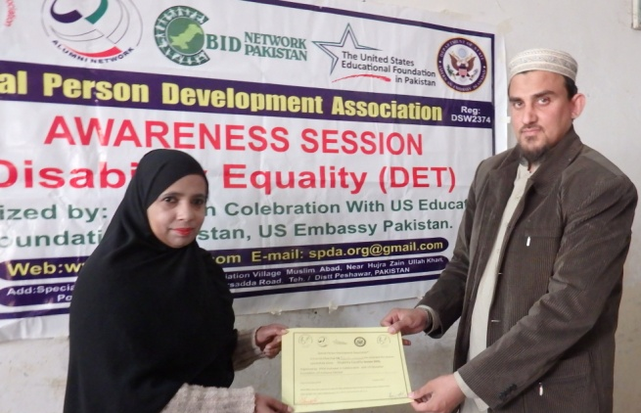
Activity Title: Disability awareness session
Date: 01/01/2016
Venue: Peshawar learning school Gulbahar
Objectives:
- To sensitize the school teachers about disability issues
- To educate the teacher how to include the children with disabilities in mainstream education system
Achievements:
- Fourteen school teachers were educated about disability and issues faced by children with disabilities
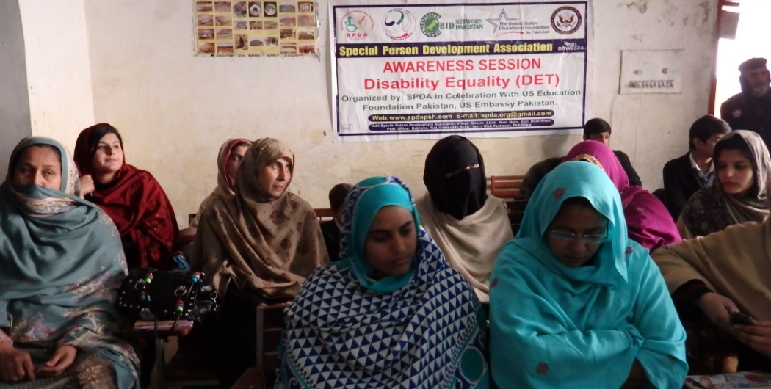
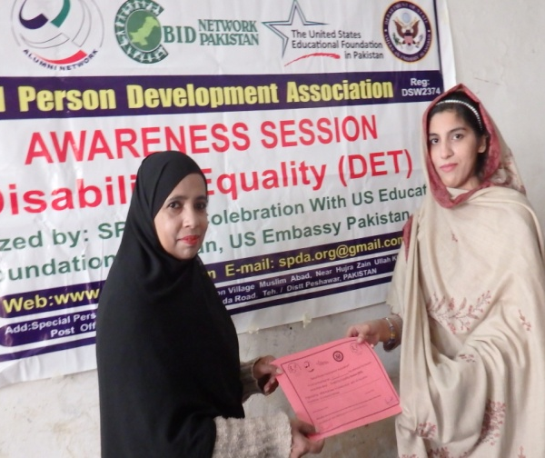
- The teachers were educated how to minor to moderate children with disabilities include in the mainstream education system.
Teachers were attending the Session while one teacher has receiving the Session Certificate
Activity Title: Disability awareness session
Date: 15/01/2016
Venue: Abaseen Public School Bakhshu Pull Peshawar
Objectives:
- To sensitize the school teachers about disability issues
- To educate the teacher how to include the children with disabilities in mainstream education system
Achievements:
- Fourteen school teachers were educated about disability and issues faced by children with disabilities
- The teachers were educated how to minor to moderate children with disabilities include in the mainstream education system.
Activity Title: Peer to peer support meeting of the parents learning children with disabilities
Date: 21/01/2016
Venue: SPDA project office Faqirabad Peshawar
Objectives: To minimize the psychosocial problems of learning children with disabilities
Achievements:
- To able the parent of teach children with disabilities how to deal their children with disabilities in their daily life.
Activity Title: One day training on disability equality.
Date: 07/02/2016
Venue: Government institute for the blind Peshawar city.
- To reach a social model of Disability as Opposed to an Individual ,charity or medical model of Disability
- To develop Plan of action with the consultation of PWDs, through which the participants in the training can make changes in their working environment and make inclusive for the PWDs.
Achievements:
Summary of the Activity / meeting:
On day training on “Disability Equality” organized by SPDA (Special Person Development Association) with the collaboration of U.S education foundation Pakistan (U.S embassy). On 7th November 2015 SPDA (Special Person Development Association) has organized one day training on “Disability Equality “
There were about 30 persons including Male and Female Teachers, Persons with disabilities and their parents, Local Govt. Officials and project staff have participated in this training
After this the questionnaire about disability equality has been given to the participant in order to find views of the participants regarding disability. Most of the participants were unable to define disability. The questioner been given to the participants has been collected. The first session has started on disability by Ihsan Ullah Daudzai. He asked the question from the participants that what you know about disability.

After discussion on disability definition according to the UN convention, after detailed discussion he told that disability is not in any individual but it depends upon the environment in which the persons with disabilities are living.

The 2nd session has started by Ihsan Ullah Daudzai about accessibility. The trainer defined accessibility with examples .He described that accessibility means easy to reach, easy to enter, easy to move and easy to use, Ihsan has described the importance of accessibility for the persons with disabilities.

After the 2nd session there was a group activity. The participants were divided in three different groups and tasks were assigned to them.

After group work the group leaders has presented the problems faced by visual impaired, physical and speech and hear impaired persons. They have also presented the solutions of the problems been arises in the group activity.The Training was very much appreciated by all the Participants
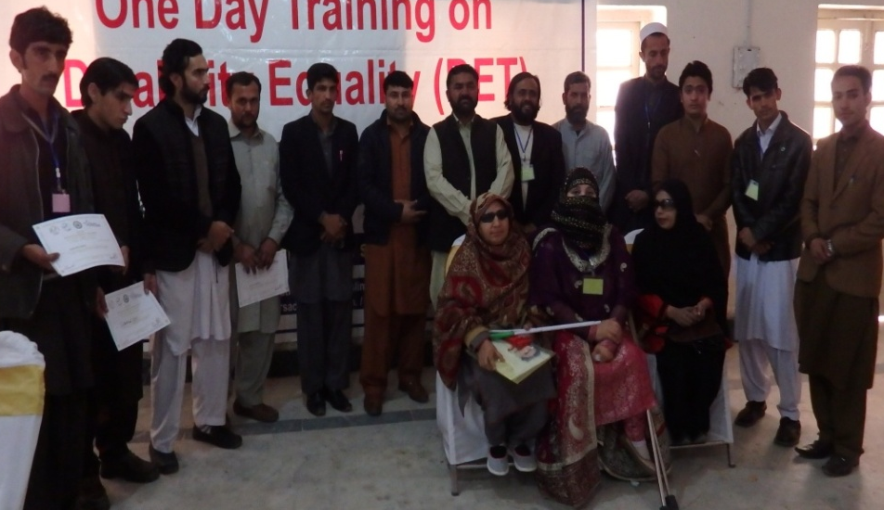
Some of the participants gave their Feedback on the session that this the first time that we realised that Disability is nothing but its different style of life, attention of the Participants during all the session was remarkable
All the SPDA Staff was thanked to the Participants
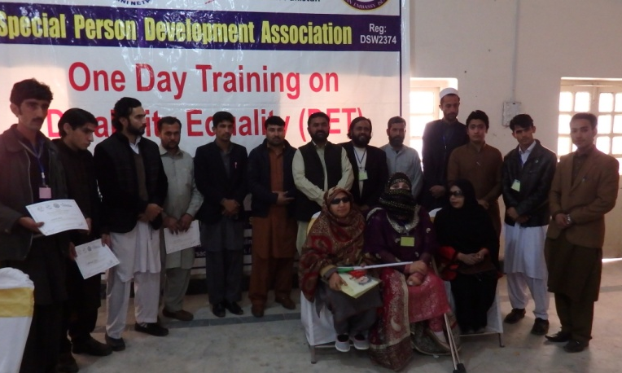
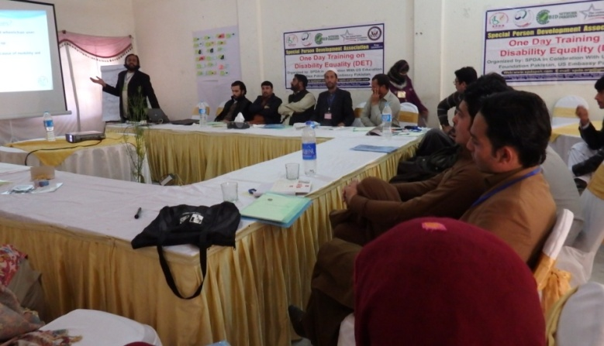
Training session in progress Group photo of the Participants after session
Activity Title: One day training on disability equality.
Date: 14/02/2016
Venue: Government institute for the blind Peshawar city.
- To reach a social model of Disability as Opposed to an Individual ,charity or medical model of Disability
- To develop Plan of action with the consultation of PWDs, through which the participants in the training can make changes in their working environment and make inclusive for the PWDs.
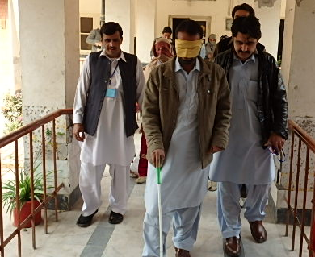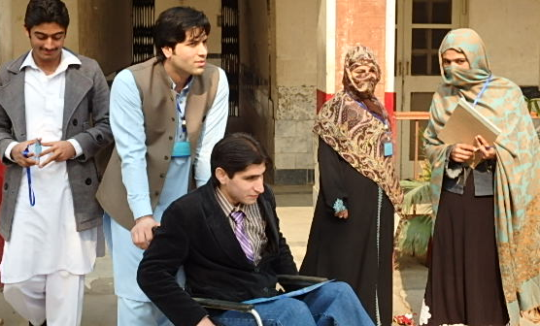
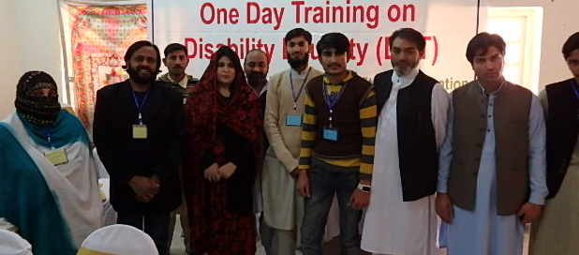
Group task to identify the Problem faced by Person with disabilities
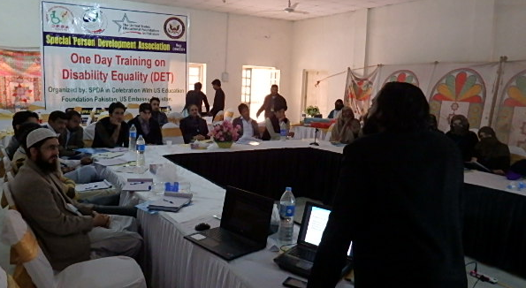
Session in progress while some participants in group after session
Achievements:
Summary of the Activity:
On day training on “Disability Equality” organized by SPDA (Special Person Development Association) with the collaboration of U.S education foundation Pakistan (U.S embassy). On 7th November 2015 SPDA (Special Person Development Association) has organized one day traion “Disability Equality “
There were about 28 persons including Male and Female Teachers, Persons with disabilities and their parents, Local Govt. Officials and project staff have participated in this training
After this the questionnaire about disability equality has been given to the participant in order to find views of the participants regarding disability. Most of the participants were unable to define disability. The questioner been given to the participants has been collected. The first session has started on disability by Ihsan Ullah Daudzai. He asked the question from the participants that what you know about disability.

After discussion on disability definition according to the UN convention, after detailed discussion he told that disability is not in any individual but it depends upon the environment in which the persons with disabilities are living.

The 2nd session has started by Ihsan Ullah Daudzai about accessibility. The trainer defined accessibility with examples .He described that accessibility means easy to reach, easy to enter, easy to move and easy to use, Ihsan has described the importance of accessibility for the persons with disabilities.

After the 2nd session there was a group activity. The participants were divided in three different groups and tasks were assigned to them.
After group work the group leaders has presented the problems faced by visual impaired, physical and speech and hear impaired persons. They have also presented the solutions of the problems been arises in the group activity.The Training was very much appreciated by all the Participants
Some of the participants gave their Feedback on the session that this the first time that we realised that Disability is nothing but its different style of life, attention of the Participants during all the session was remarkable

All the SPDA Staff was thanked to the Participants

Activity Title: Disability awareness session
Date: 12/02/2016
Venue: National Model Public School Zaryaab Colony.
Objectives:
- To sensitize the school teachers about disability issues
- To educate the teacher how to include the children with disabilities in mainstream education system
Achievements:
- Fourteen school teachers were educated about disability and issues faced by children with disabilities
- The teachers were educated how to minor to moderate children with disabilities include in the mainstream education system.
Activity Title: Disability awareness session
Date: 13/02/2016
Venue: Modern Learning Public School.
Objectives:
- To sensitize the school teachers about disability issues
- To educate the teacher how to include the children with disabilities in mainstream education system
Achievements:
- 18 school teachers were educated about disability and issues faced by children with disabilities
- The teachers were educated how to minor to moderate children with disabilities include in the mainstream education system.
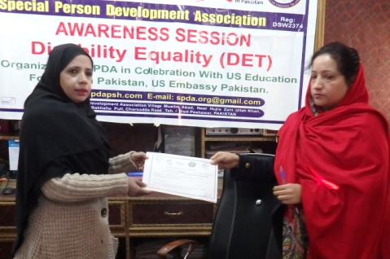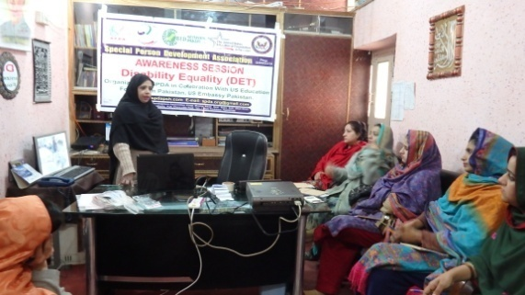
Activity Title: Disability awareness session.
Date: 15/02/2016
Venue: The Qaaid public school inside Lahori gate Peshawar city.
Objectives:
- To sensitize the school teachers about disability issues
- To educate the teacher how to include the children with disabilities in mainstream education system.
Achievements:
- 11 school teachers were educated about disability and issues faced by children with disabilities
- The teachers were educated how to minor to moderate children with disabilities include in the mainstream education system.
Activity Title: Organization management training
Date: 20/02/2016
Venue: SPDA project office Faqirabad Peshawar City.
Objectives:
- To enhance the capacity of the executive members of SPDA.

Achievements:
- The SPDA executive member abled to organized the association activities in a better manner.
Activity Title: PCRDP Meeting (Provincial Council for the Rehabilitation of Disabled People)
Date: 26/02/2016
Venue: Directorate of Social Welfare Conference Hall University Town Peshawar.
Objectives:
- To finalize the minutes of last meeting.
- To give approval of financial aid for persons with disabilities.

Achievements:
- The last meeting minutes were finalized and have given the approval of financial aid for persons with disabilities.

Activity Title: Meeting with Peshawar university students.
Date: 03/03/2016
Venue: SPDA project office Faqirabad Peshawar.
Objectives:
- To arrange a session for the students of Peshawar university on disability awareness.
Achievements:
- Finalized the date and venue for the session of engineering university students.
Activity Title: Disability Awareness Session for University students.
Date: 10/03/2016
Venue: SPDA Head Office Bakhshu Pull Peshawar.
Objectives:
- To sensitize the university students about disability issues
- To educated them how to include the children with disabilities in mainstream education system.

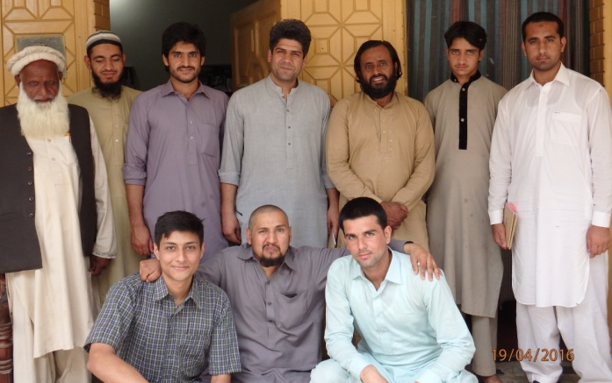
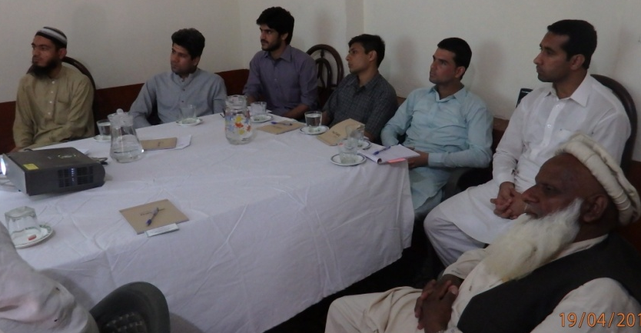

Peshawar University students during the session and After Session
Achievements:
- The university student been abled in understanding the disability issues. They have educated to include the children with disabilities in mainstream education system.
Activity Title: Follow up training on child safeguarding.
Date: 30/04/2016
Venue: Islamabad Hill View Hotel.
Objectives:
- To review on previous training on child safeguarding and child protection.
Achievements:
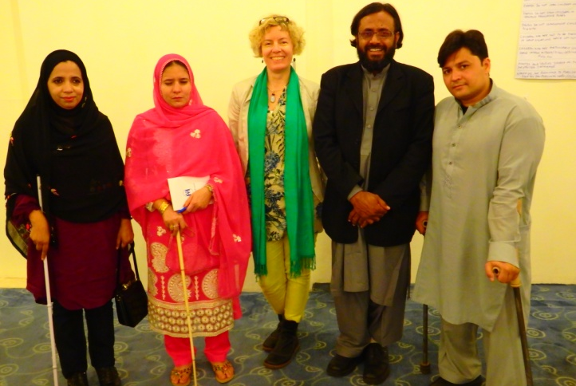
- The action plan was finalized for SPDA staff, executive members and volunteers on child safeguarding session.

Activity Title: PCRDP Meeting
Date: 26/05/2016
Venue: Conference Room of Directorate of Social Welfare Peshawar.
Objectives:
- To finalize the micro credit scheme for persons with disabilities. After session on Child safeguarding

Achievements:
- The micro credit scheme for person with disabilities was finalized.

Activity Title: Ramzan food package distribution.
Date: 28/05/2016
Venue: Amir shadi Hall Gulbahar Peshawar
Objectives:
- To provide food items to persons with disabilities, widows, orphan and other poor people of the Peshawar district.
Achievements:
216 food packages were distributed among the PWDs, widows, orphans, and other vulnerable community. This was full food package for 1 month to average family (5-7) persons. The package was donated by Ummah welfare Trust Pakistan. From 2013 every year Ummah welfare Trust provide the Package and SDPA is providing the distribution facility. SPDA has provided some food packages on the PWDs home, the entire Beneficiary has appreciated the activity and thanked to Ummah and SDPA.
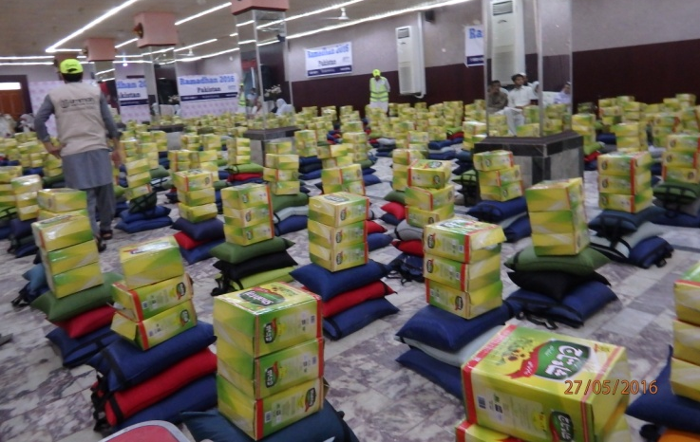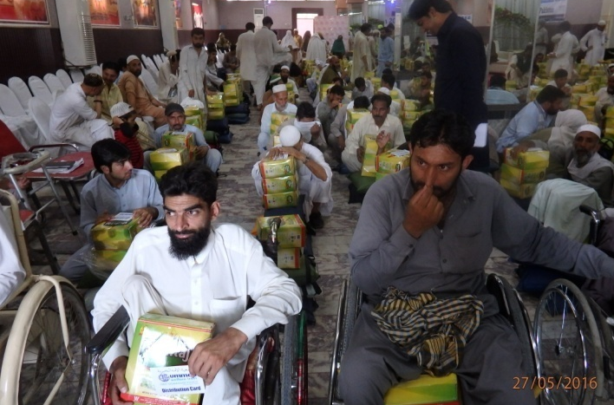
Activity Title: CBM project staff meeting with executive members of SPDA
Date: 07/06/2016
Venue: SPDA project office shinwari town Gulbahar Peshawar.
Objectives:
- To give orientation about the CBM and SPDA project “social inclusion of learing children with disabilities.

Achievements:
- The executive members of the SPDA have been introduced with the project staff.
- Project orientation has been given about the social inclusion of learning children with disabilities.
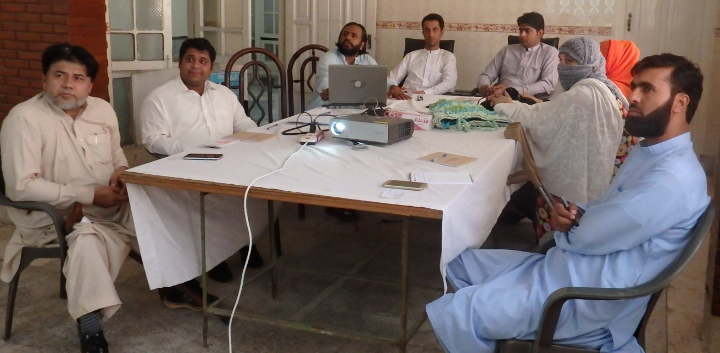
Activity Title: Session about accessibility and disability with new project staff
Date: 09/06/2016
Venue: SPDA project office shinwari town Gulbahar Peshawar.
Objectives:
- To aware the project staff about disability and accessibility.

Achievements:
- The project staff has been aware about disability and accessibility.

Activity Title: Services mapping about the services for persons with disabilities.
Date: 15/06/2016
Field areas: District Peshawar
Objectives:
- To gain information about the available services for persons with disabilities in Peshawar area.

Achievements:
- A database has been formed about the services for persons with disabilities in the Peshawar area.

Activity Title: Formation of project steering committee

Date: 22/06/2016
Venue: SPDA office shinwari town Gulbahar Peshawar.
Objectives:
- To form a committee for smoothly running of the project activities.
Achievements:
- 3 members from SPDA executives and 1 project officer have been nominated as project steering committee members.
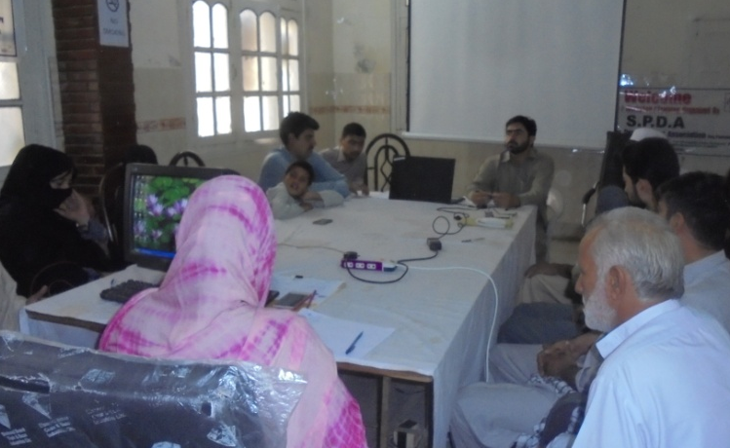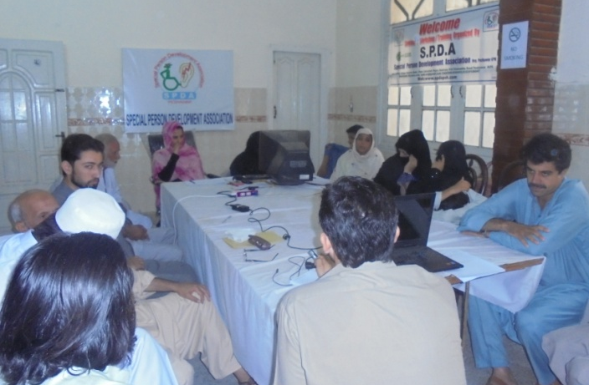

Activity Title: PCRDP Meeting
Date: 12/07/2016
Venue: Conference Room of Directorate of Social Welfare Peshawar
Objectives:
- To give approval of the previous meeting minutes
- Formation of committee for the categorization of persons with disabilities micro finance scheme.
Achievements:
- Previous meeting minutes have been approved.
- 7 members committee have been formed for the categorization of persons with disabilities.
Activity Title: Project steering committee meeting
Date: 13/07/2016
Venue: SPDA office shinwari town Gulbahar Peshawar.
Objectives:
- To discuss the previous month activities of the project.
Achievements:
- 3 months project plan has been approved.
Activity Title: Session on child safeguarding/child protection
Date: 14/07/2016 Venue: SPDA office Gulbahar Peshawar
Objectives:
- To conduct session with SPDA executive members and volunteers about child safeguard and child protection. .
Achievements:
- A session has been conducted with SPDA executive members and volunteer about child safeguard and child protection.
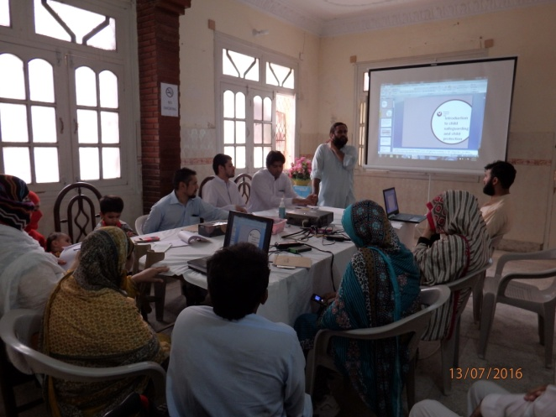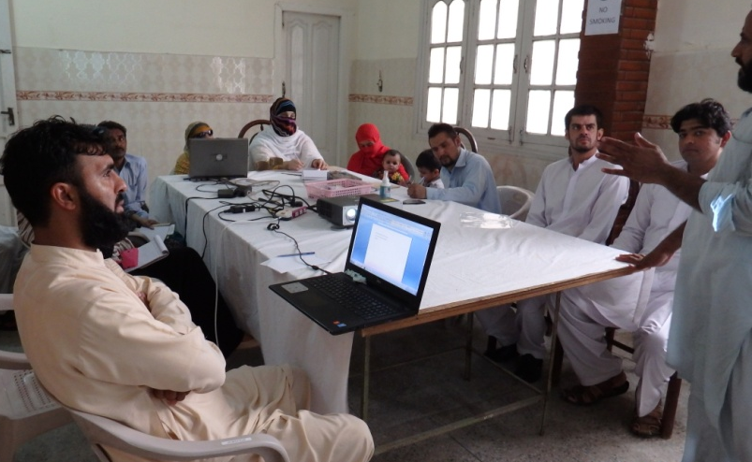
Activity Title: Recreational activity for children with learning disability.
Date: 24/07/2016Venue: Jinnah park district Nowshehra
Objectives:
- To provide an opportunity for the recreation of learning children with disabilities.
- To make enabled the learning children with disabilities in performing different types of recreational activities. .
Achievements:
- An opportunity has been provided for the recreation of learning children with disabilities.
- The learning children with disabilities have been made enable to perform different types of recreational activities.
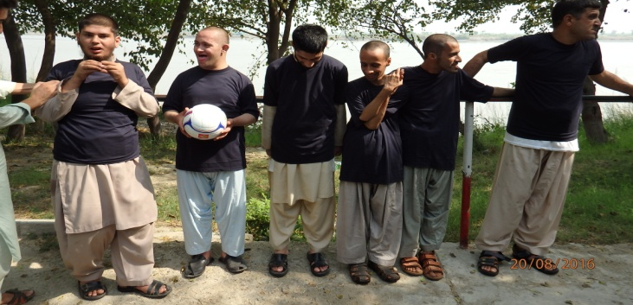
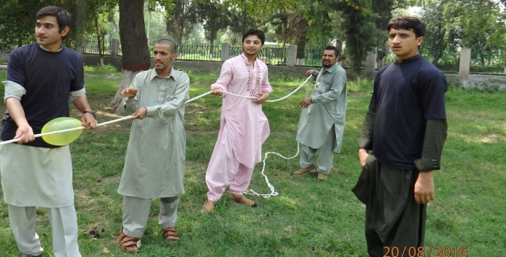

Activity Title: Signing of MOU with project officer of Helpage International.
Date: 28/07/2016 Venue: SPDA project office shinwari town Gulbahar Peshawar.
Objectives:
- To sign the memorandum of understanding for the better coordination among SPDA and Helpage International.
Achievements:
- Coordination among SPDA and Helpage International has been made for better
Understanding.
Activity Title: Sports tournament for PWDs
Date: 13-08-2016 Venue: Qayoom Sports complex Peshawar
Objectives:
- To provide recreational opportunity to PWDs and include them in the society.
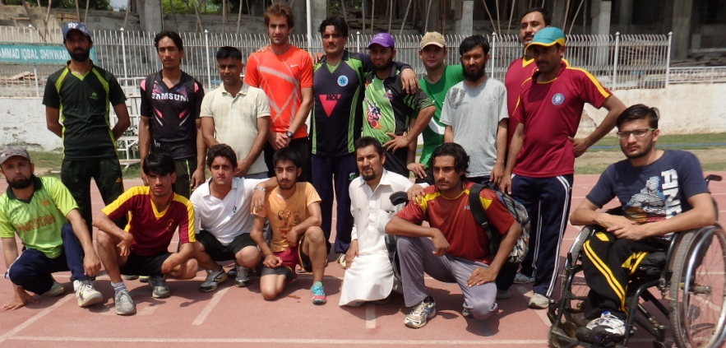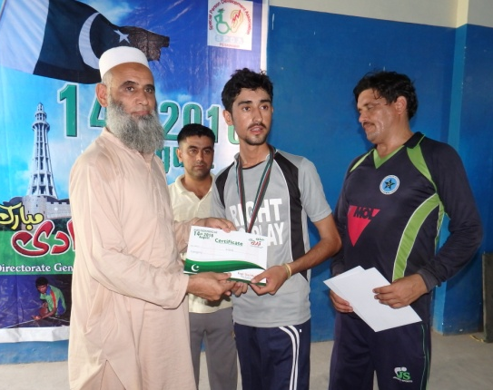

Achievements:
More than 20 PWDs have been participated in the activity
Activity Title: Activities Daily Living training for the Parents of LCWDs
Date: 22-24 September 2016. Venue: Shelton Guest house University town Peshawar
Objectives:
- To educate the parents of LCWDs about daily Living Activities
- To aware the Parents of LCWDs that how to deal their LCWDs in Daily life
Achievements:
More than 24 parents were aware about the ADL in practical manner
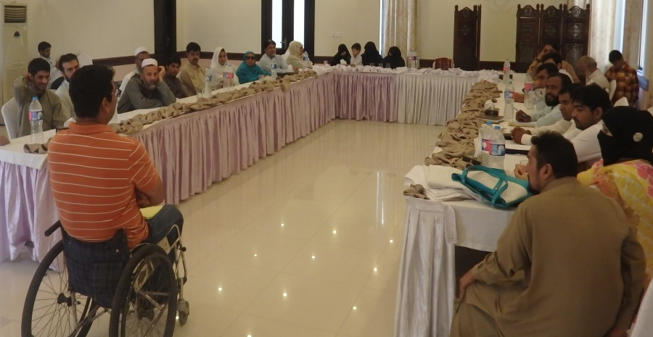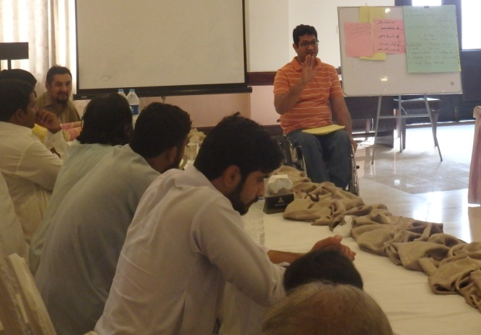
Activity Title: Meeting with deputy speaker of provincial assembly Khyber pukhtunkhwa.
Date: 23/09/2016 Venue: Provincial assembly secretariat Peshawar.
Objectives:
- To speed up the work on disability act 2014.
- To approve the 2014 act from the provincial assembly of khyber pukhtunkhwa as early as possible
Achievements:
- On disability act 2014 the work has been expedite.
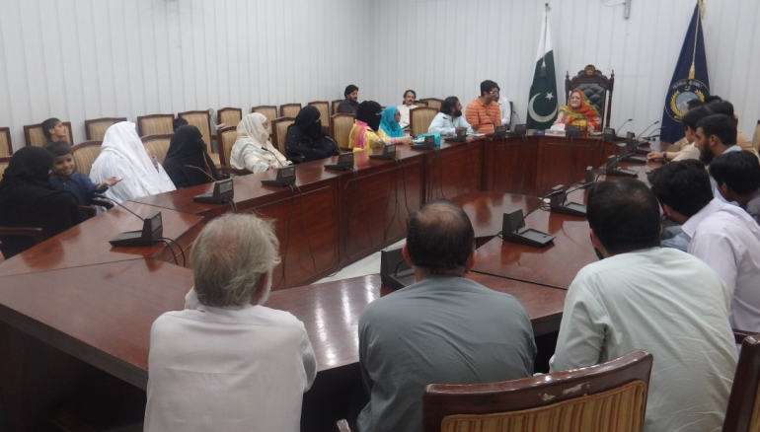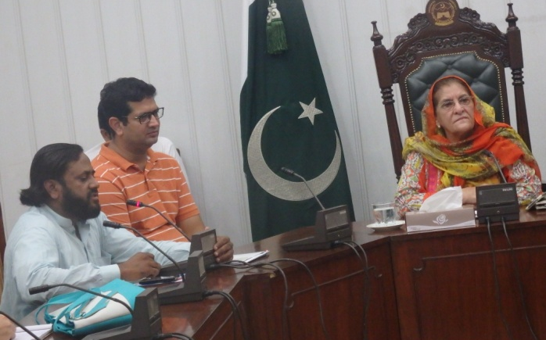Activity Title: Celebration of white cane day
Date: 15-10-2016 Venue: Chongi Squire main Khyber road Peshawar cantt
Objectives: To awere the genral public about the Importance of white cane day
Achievements: 1000 Pamphlets were distributed among the general public and them aware
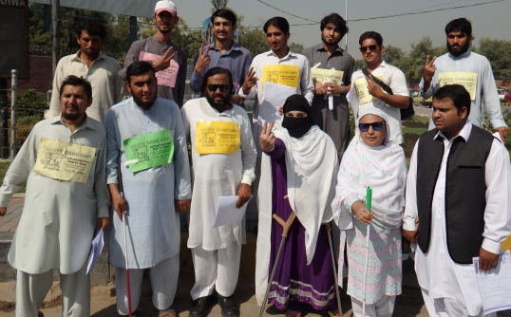
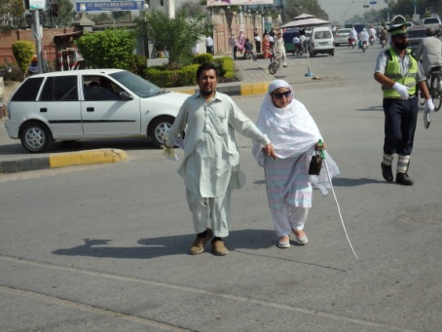
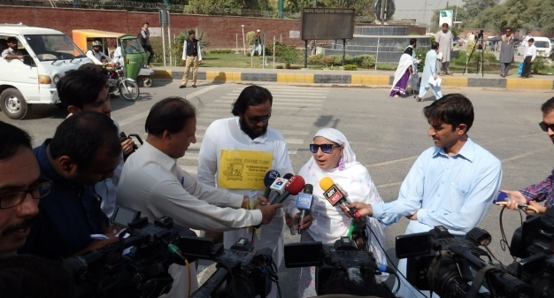

Activity Title: Staff training of Institute Rural Development Organization
Date: 26-10-2016, Venue: Conference Hall of IRM Nowshra District
Objectives: To aware the staff of IRM about the Disability and Accessibility
Achievements:
16 Staff member have been participated in the one day training session and they were aware about the Disability and Accessibility

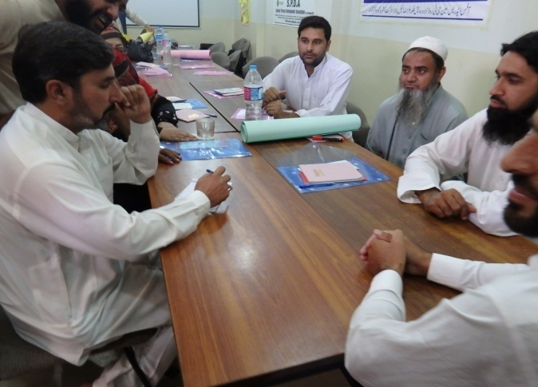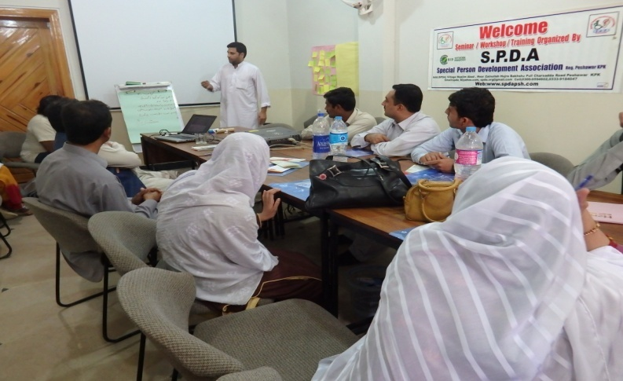
Activity Title: Meeting of Women with disabilities wing SPDA
Date: 07-10-16 Venue: SPDA Project office Shinwari Town Gulbahar Peshawar
Objectives: To organized the women with disabilities to fight their rights
Achievements: The women with disabilities have been motivated to start straggle for their own rights
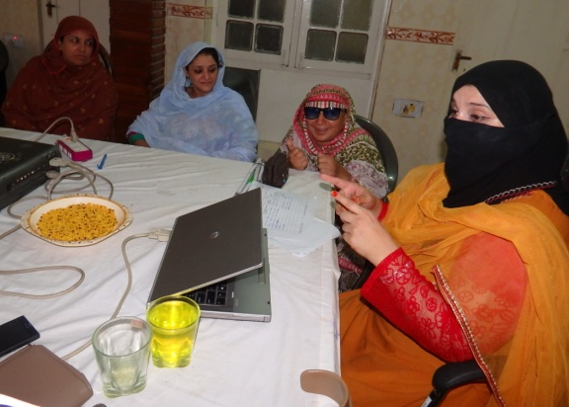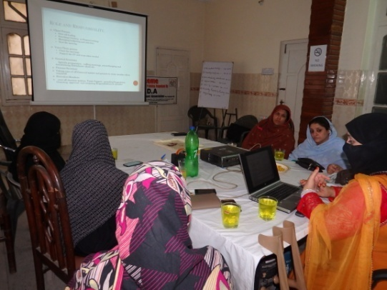
Activity Title: Leader ship training for person with disabilities
Date: 03rd December 2016 Venue: Pehsawar Medical collage warsak road Peshawar
Objectives:
- To build the capacity of PWDs and Enhance their leader ship skill for better advocacy and strengthen the disability movement in Khyber Pukhtoonkhawa.
Achievements: SPDA has successfully built the capacity of 25 PWDs leaders and equipped them with leader ship skills.
SPDA has made the collaboration with Urat Foundation and Pakistan association of the Blind more than 150 Participants were attended the seminar. Media officials, member of provincial assembly, and many PWDs were participated.
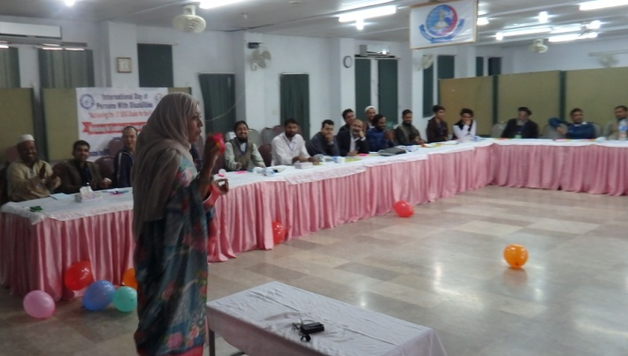
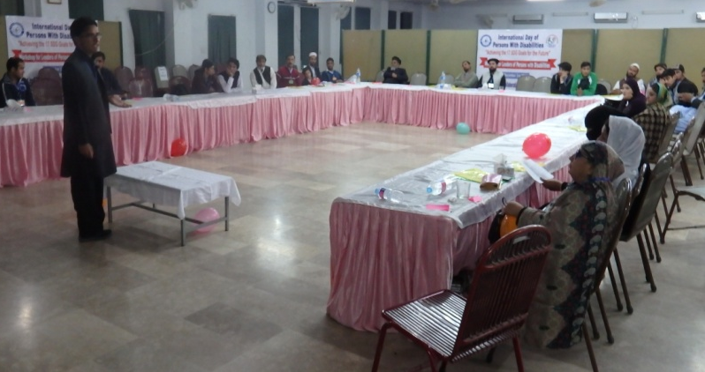
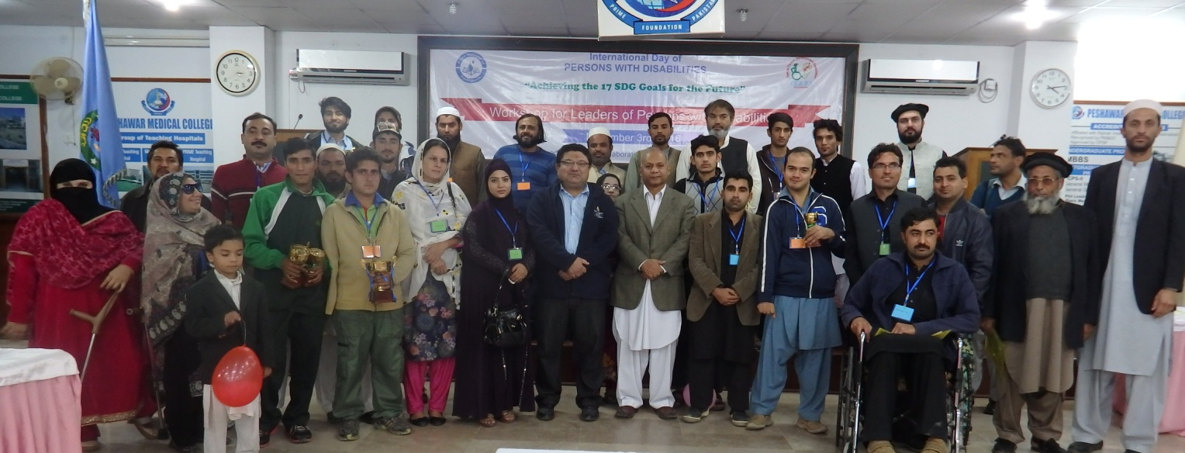
Note: There many other Meeting (Monthly Executive body meetings, special meetings of EOB, meeting of women with disabilities, annual general body meetings ,were organized by SPDA and Have attended many national and Provincial level work shops, seminars not been mention due limited space in the report section .
The following individuals, representatives of different NGO’s, Government officials and relevant stakeholders have visited SPDA office during last year (2016). Most of them have given very good remarks and appreciated the activities of the association.
Serial No | Name of the officials | Organization/Institute/Department | Date of visit
1 | Mr. Zakia Zahid | Ex. Teacher Govt. Girls School | 02/01/2016
2 | Mr. Shawaz Khan | General Councilor Union Council Faqirabad | 3/02/2016
3 | Mr. Gohar Rehman | Rafsaan Nuero Rehab Center | 03/01/2016
4 | Mr. Arshad Ali Khan  Mr. Zahid Ali Khan |  | 03/03/2016
5 | Mr. Gulzar Ali | Disabled People Organization District Chitral | 04/04/2016
6 | Mr. Noor Alam Khan | Ex. Member of National Assembly | 10/05/2016
7 | Mr. Hamayun Sayyad | Student of Peshawar University | 26/05/2016
8 | Ms. Zelle Huma | Lecturer Agricultural University Peshawar | 08/06/2016
9 | Mr. Dr. Muhammad Jahangir | Help Age | 15/06/2016
10 | Ms. Shakila Malik | Help Age | 29/06/2016
11 | Mr,Farhat Abbas | Chief Editor of Monthly Pakistan Special | 15/07/2016
12 | Mr. Fida Muhammad | General Councilor Shaheen Muslim Town Peshawar | 21/07/2016
13 | Mr. Nabil Shaukat | Nowpdp | 30/07/2016
14 | Mr. Adnan Ullah | Government Servant | 20/08/2016
15 | Mr. Shafiq Ur Rehman | President Milestone Lahore | 21/09/2016
16 | Mr. Ashar Virk | Milestone Lahore | 21/09/2016
17 | Mr. Asif Khan and Sayyad Khan | Chief Executive Sayyad Welfare Organization | 27/12/2016
18 | Mr. Sajid Ali | Sayyad Welfare Organization | 27/12/2016
19 | Malik Firdos khan | District Member UC Haryana payan | 28/12/2016
20 | Ms,Asma Malik | CEO, The Soul welfare Organization | 29/12/2016
21 | Shukat yousef zai | Member of Provincial Assembly KPK | 30/12/2016
In Short there are so many other guests which not been mentioned above due to limited space have visited the SPDA Office and appreciated the work done by the SPDA for the promotion of PWDs.

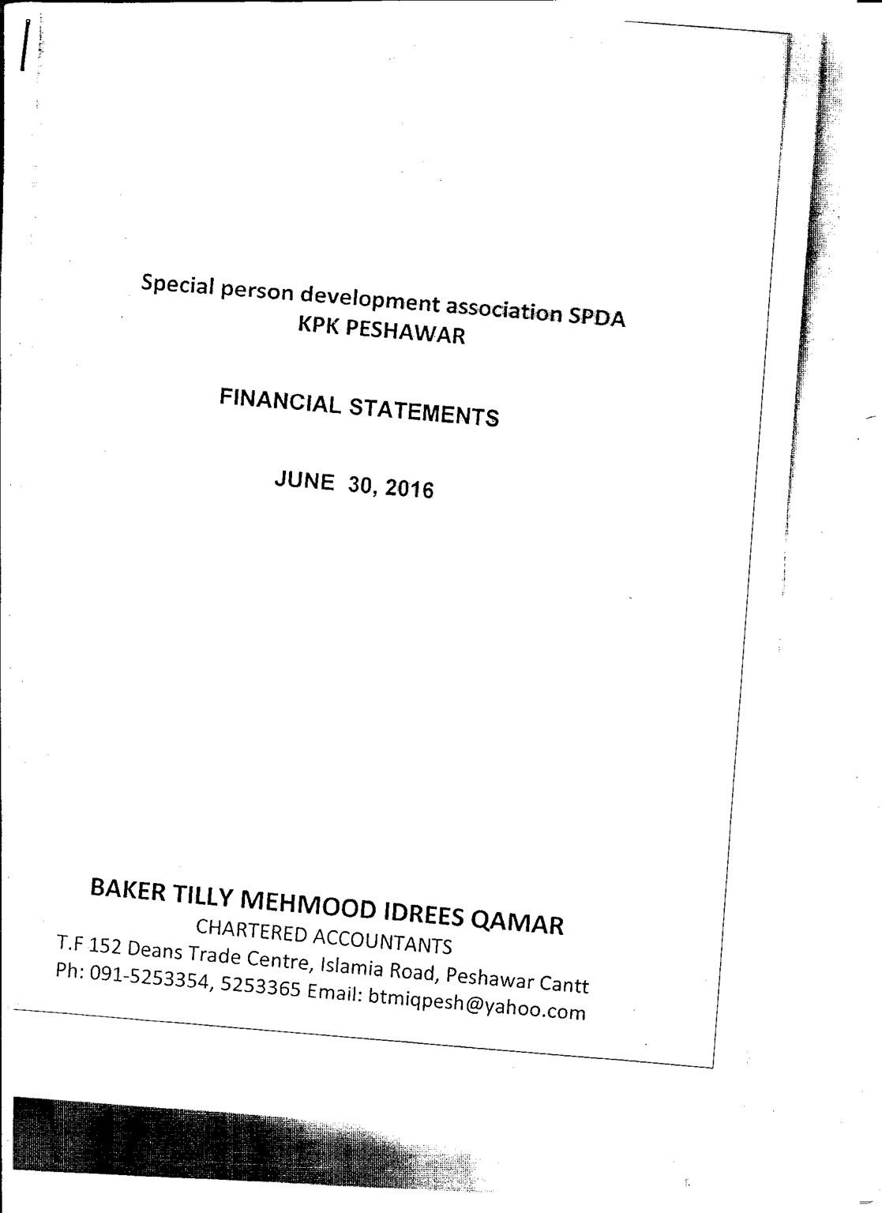

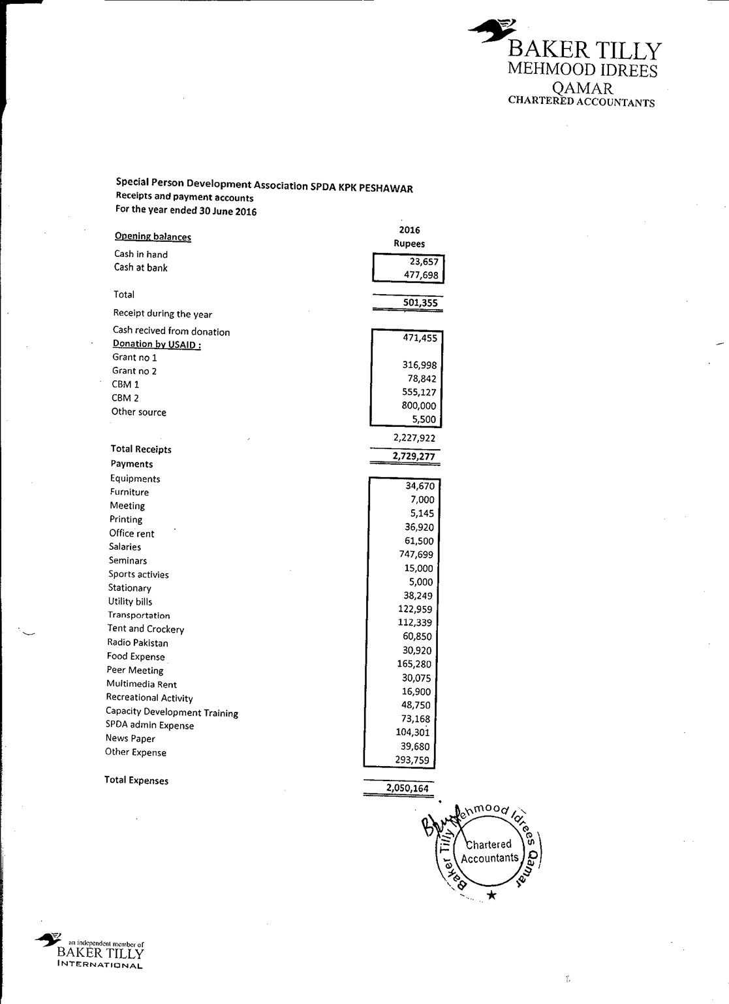
Report Prepared By: Javed Khan,Ms.Mehar Un Nissa ,Sabir ullah
Presented to: Executive board of SPDA

