Annual General Report of SPDA (Special Persons Development Association)
(January to December 2015)

2016
Special Persons Development Association (Reg) Peshawar KPK Pakistan
Ihsan ullah (15-01-2016) (DAS Session) (US Embassy)

Activity Title: Meeting with Speaker provincial assembly Khyber Pukhtoon Khwa Pakistan.
Date: 05-01-2015
Venue: Assembly House Secretariat Khyber Road Peshawar
Objectives:
- Briefing about SPDA.
- Discussion about Implementation of 2% Quota for Persons with Disabilities.
- Present Grant application to Mr. Speaker of Khyber Pukhtoon Khwa
Achievements:
Mr. Speaker has appreciated the activities of SPDA, and issued Order to Secretaries and administrative of all departments to insure the 2% quota reserved for PWDs. He also forwarded the grant Proposal of SPDA to finance department for further approval as per rules.
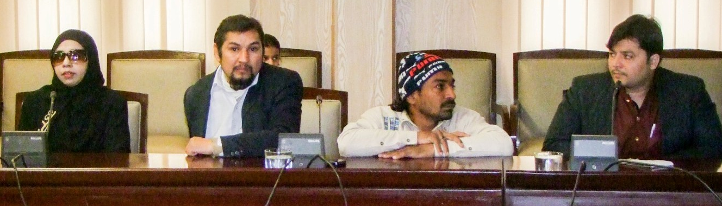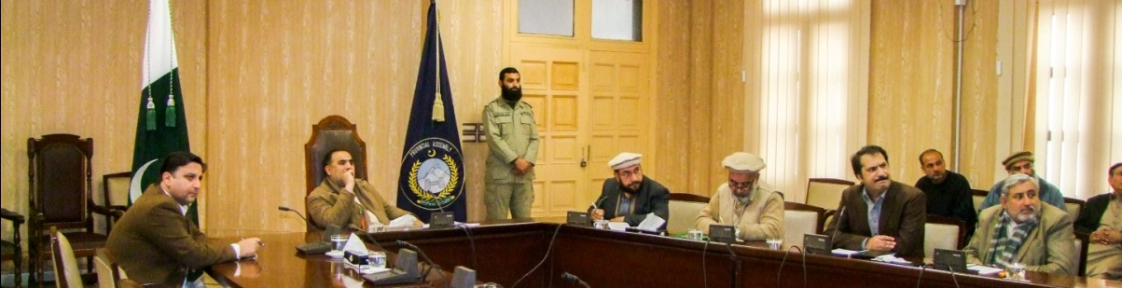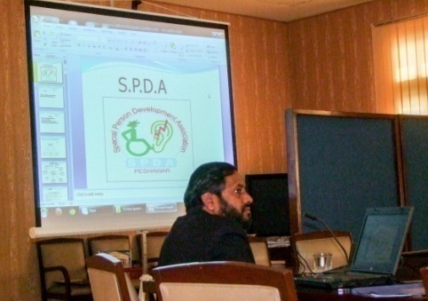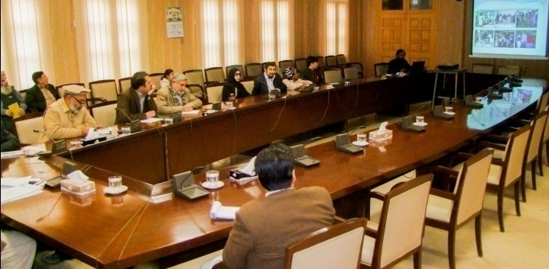

Activity Title: Services Mapping
Date: 09-02-2015
Venue: Special Education Complex Pajaggi Road Peshawar
Objectives:
- To assess the relevant stakeholder/Organization, to utilized their Services for our Beneficiary and make with them referral mechanism.

Achievements: Collected all the data from Institute and make with them the referral mechanism, they have agreed to provide services to our beneficiaries.
Activity Title: Services Mapping
Date: 10-02-2015
Venue: Govt Technical and Vocational Centre Gulbahar Peshawar
Objectives:
- To Identify potential services Providers
- To assess the relevant Stakeholder/Organization, to utilize their Services for our Beneficiary and make with them referral mechanism.

Achievements: Collected all the data from Institute and make with them the referral mechanism, they were agreed to provide services to our beneficiaries.
Activity Title: Services Mapping
Date: 11-02-2015
Venue: Special Education Complex Hayat Abad Peshawar
Objectives:
- To Identified potential services Providers
- To assess the relevant stakeholder/Organization, to utilized their Services for our Beneficiary and make with them referral mechanism.
Achievements: Collected all the data from Institute and make with them the referral mechanism, they have agreed to provide services to our beneficiaries.
Activity Title: Services Mapping
Date: 12-02-2015
Venue: District Social welfare office Bacha Khan Peshawar
Objectives:
- To Identified potential services Providers.
- To assess the relevant stakeholder/Organization, to utilized their Services for our beneficiary and make with them referral mechanism.
Achievements: Collected all the data from Institute and make with them the referral mechanism, they have agreed to provide services to our beneficiaries.
Activity Title: Services Mapping
Date: 12-02-2015
Venue: Vocational Training Center for PWDs Phase 5 Hayat Abad.
Objectives:
- To identify potential services Providers.
- To assess the relevant Stakeholder/Organization, to utilize their Services for our beneficiary and make with them referral mechanism.
Achievements: Collected all the data from Institute and make with them the referral mechanism, they have agreed to provide services to our beneficiaries.
Activity Title: PCRDP Meeting
Date: 31-02 2015
Venue: Directorate of Social Welfare Department Govt. of Khyber Pukhtoon Khwa.
Objectives: To finalize the financial aid Distribution plan for PWDs and Procedures.
Achievements: SPDA is a representative organization of all PWDs in the council; SPDA has requested the council to make sure the procedure of financial aid easy accessible and transparent.
Activity Title: Orientation meetings about the project activities with Fathers and Mothers of LCWDs (Learning Children with Disabilities)

Date: 01-03 2015
Venue: SPDA Office
Objectives:
- To aware the parents of LCWDs about project activities.
- To aware the Parents of LCWDS from the Importance of Special CNIC and form “B” for all the Beneficiaries.
- To discuss the practical plan for making CNIC and form “B”.
- To finalize the schedule for making CNIC and form “B” from NADRA offices Peshawar.

Achievements: The parents have shared their problems with each other’s and minimized their stress. They realized that we should give more attention to change the bad habits of our Kids with passion, tolerance and support.
Moreover all parents came to know about the process of making CNIC and form “B” from NADRA offices Peshawar.
Activity Title: Services Mapping
Date: 11-03-2015
Venue: Kuwait Teaching Hospital University Road Peshawar
Objectives:
- To identify potential services providers for our beneficiaries.
- To assess the relevant Stakeholder/Organization, to utilize their Services for our beneficiary and make with them referral mechanism.
Achievements:
The Hospital Administrator has offered the Services, as SPDA and Kuwait Hospital already have understanding on this issue. The Hospital administration has issued the notification of 50% discount in all facilities to all PWDs of KPK.
Activity Title: 1st Recreational Tour for LCWDs with their Parents
Date: 22-03-2015
Venue: Islamabad
Objectives:
- To provide recreational opportunities to LCWDs.
- To minimize the stress of parents due to LCWDs dealing in daily life.
- To Involve LCWDs in productive and positive activities (playing sports competition).
- To educate the parents how they can involve their children in some positive and recreational activities.
Achievements:
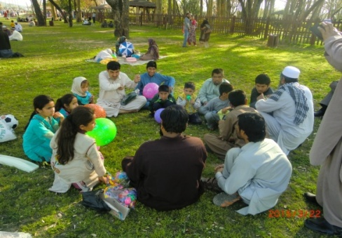
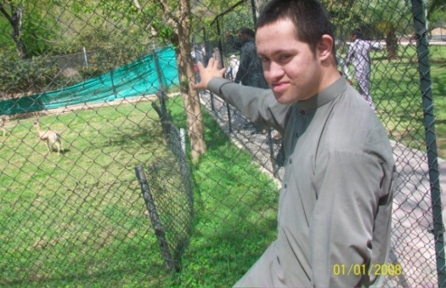
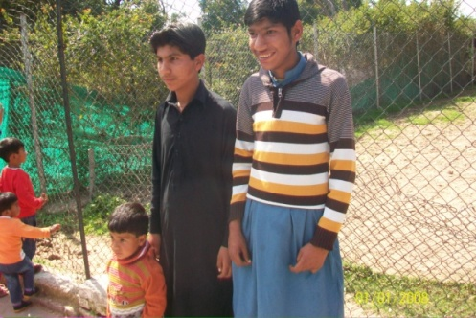
The recreational activity was arranged according to plan on quarterly basis .It was first trip of LCWDs outside their home town. This time, Islamabad was selected for one day trip for LCWDs to visit Marghuzar Zoo and Rawal Lake Park on 22nd of March, 2015 on Sunday. SPDA have been provided to recreational opportunities to all LCWDs, to minimize stress of parents in dealing LCWDs in daily life as well as to provide productive and positive activities. The parents have been able how to involve their children in positive and recreational activities. The SPDA team has given suggestions and practical demonstration to the parents by involving their children in physical and sports activities.
Activity Title: Peer to peer, meetings (Father and Mothers of LCWDs)
Date: 31-03 2015
Venue: SPDA Sub Office: Street No. 4 Nawaz Abad Zaryab Colony Peshawar city.
(Mid in the city, Convenient to all Participants)

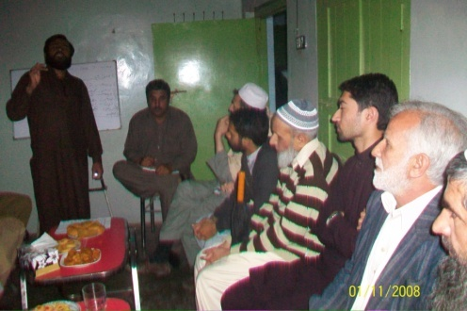
Objectives:
The main objective of the peer parents meeting was to share the problems of LCWDs.
To use peer counseling techniques.
To adopt the good practices to handle the LCWDs in home and family and how to include their children in social activities and minimize psychosocial problems of LCWDs.
Achievements:
After detail meeting and discussion the following solution were presented to the parents.
- Try to understand that disability is different style of life and your CWLDs/PWDs is different from other people and need more attention.
- Try to understand what is the need of your CWLDs/PWDs? And what they want to do and try to busy them in some recreational activities.
- We are living in a Poor country and there most of the people are poor and we all have limited resources and poor financial condition. They should try to manage their expenses according to financial status.
- We all should try to find out and provide some vocational and educational opportunities to our CWLDs/PWDs.
- Try to give some time in weekly basis and take the CWLDs/PWDs in some parks/lawns and provide them opportunities for playing and running.
- Try to remain busy yourself in some positive activities and ignore your problems and grief.
Activity Title: Capacity development training of DPOs representative and social welfare department officials KPK Pakistan by JICA Japan
Date: 06th April to 22 April 2015
Venue: Tokyo Japan JICA center
Objectives: To understand disability and Independent Living, Rehabilitation of PWDs
Achievements:
Mr. Javed Khan Finance Secretary of SPDA was the team member of the delegation. He visit to different institutes in Japan and Learn many things new techniques and then he share his experience with SPDA members.

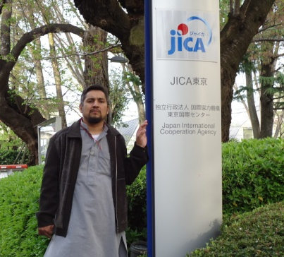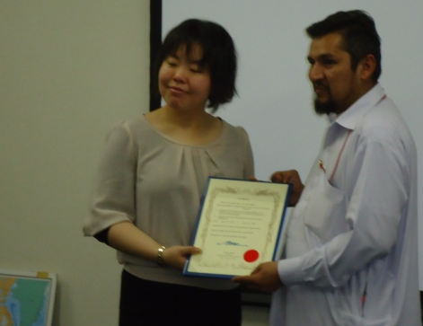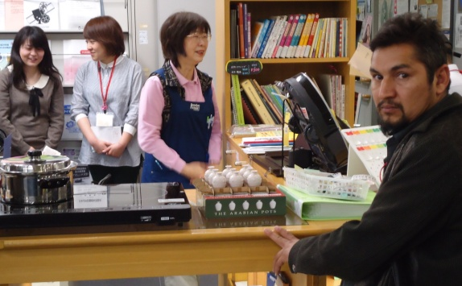
Activity Title: Peer to Peer meeting
Activity Title: Assessments of LCWD’s in educational and vocational training centers.
Date: Tuesday 21st April 2015, Wednesday 22nd April 2015, Friday 24th April 2015, Tuesday 28th April and 29th April 2015
Venue: Special Education Complex phase 5 Hayat Abad Peshawar
Objectives:
- To assess the PWDs/CWDs (Children with Disabilities) for education.
- To assess the PWDs/CWDs (Children with Disabilities) for vocational training.
- To make referral mechanism for education and vocational centres.
Achievements:
On 21st April assessment was done in vocational training centre for eight CWLDs (Children with learning Disabilities). All the eight CWDs were gone through the process and only three CWLDs were selected for final assessment. M.ismail, M.Ibrahim and Kashif were selected. The remaining CWLDs were rejected on over age and educational grounds.
On 22nd April remaining six children were taken for assessment. After completing assessment procedure, only two children were Mubashir and jawad Ahmad selected for final assessment. Others were rejected again on over age and educational ground.
On 24th April 2015, all five CWLDs were gone through final assessment process. Mubashir was advised to be remained in Govt. school among normal children. Three CWLDs M.ismail, M.Ibrahim and Jawad Ahmad were recommended for MRC (Mentally Retarded centre) Hayatabad and Kashif to MR&PH (Mentally Retarded and physically handicapped centre) pajaggi road Peshawar.
On 28th April 2015 three children M.ismail, M.Ibrahim and jawad Ahmad were brought for admission in MRC Hayatabad Peshawar. Going through final assessment and admission process, admitted in the centre. All three children were exempted from admission fee and other charges. Their routes were finalised with the drivers.
On 29th April 2015 Kashif was taken to MR&PH centre pajaggi road Peshawar for admission. The route was finalised with the driver and got free admission in the centre.
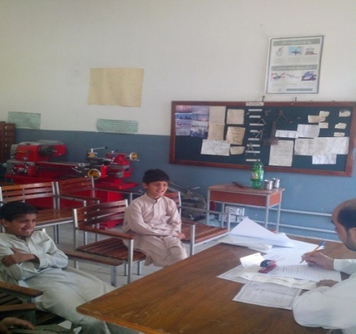
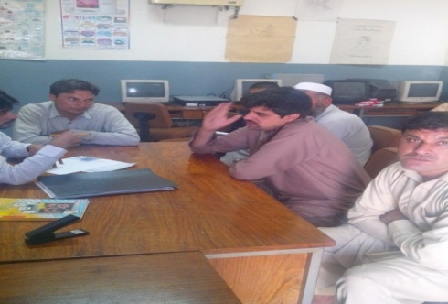

Date: 30-04-2015
Venue: SPDA sub Office Faqir Abad Street no 4 Hussain house Peshawar city
(Mid in the city, Conveyance of all Participants)
Objectives:
The main objective of the peer parents meeting was to share the problems of LCWDs, to use peer counseling techniques, to adopt the good practices to handle the LCWDs in home and family and how to include their children in social activities and minimize psychosocial problems of LCWDs.
Achievements:
The mothers shared their good practices with each other in detailed. The mother of M.ismail and M.Ibrahim told that there should be other activities in summer vacations for the children. The mother Mubashir told that always keep children busy in positive activities at home and outside home. The mother Kashif told that her child needs some playground for sports activities. The mother of Jawad ahmad told to the mothers that mothers should utilize the time with children at home in a positive way and keep busy her child in some useful activities. Others mothers also shared their good and useful experiences with other mothers. The peer mother also shared good experiences with other mothers which she has done at home with her child.
Activity Title: Meeting with Director Special education complex phase 5 Hayat abad Peshawar
Date: 07-05-2015
Venue: Special Education Complex phase 5 Hayat Abad Peshawar
Objectives:
- Develop Partnership for LCWDs Services
- Discuss admission Process of LCWDs

Achievements:
Principal of the Institution has agreed to support the LCWDs for type of services
Activity Title: Peer to Peer meeting
Date: 28-05-2015
Venue: SPDA sub Office Faqir Abad Street no 4 Hussain house Peshawar city
( mid in the city , Conveyance of all Participants )
Objectives:
The main objective of the peer parents meeting was to share the problems of LCWDs, to use peer counseling techniques, to adopt the good practices to handle the LCWDs in home and family and how to include their children in social activities and minimize psychosocial problems of LCWDs.
Achievements:
After detail discussion the following solutions were presented to the participants:
- The facilitator told them that there are private workshops for their children where they can learn skills.
- The facilitator pointed out them that always have less dependence on institution and have self support behaviour of parents should be first one.
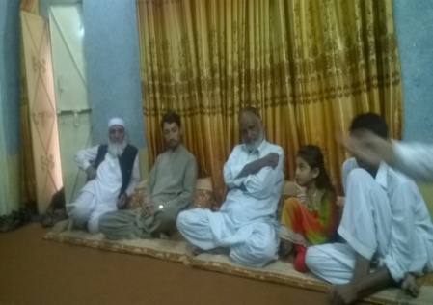
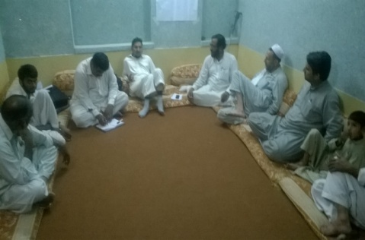
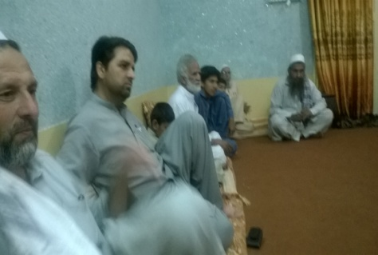
- The facilitator pointed out that all these children are from God side and never think them burden which is a sin and inhumanity.

Activity Title: Recreational Tour
Date: 13, 14 -06 -2015
Venue: Bahrin the valley of swat KPK
Objectives:
- Provide recreational opportunities to the Parents of LCWDs
- To minimize the stress of Parents and their PWDs Kids
- To Involve LCWDs in productive and positive activities (Playing sports competition).

Achievements:
All the Parents enjoy the tour a lot and most of them came first time to swat valley, all persons with disabilities also enjoy the 2 day trip of this beautiful place. Especially the weather was very much pleasant as these places are famous for pleasant weather and tourist are coming from all over the Pakistan
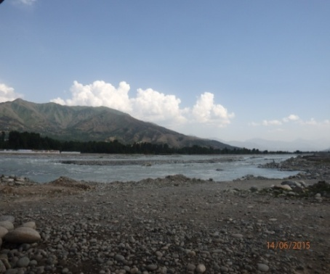
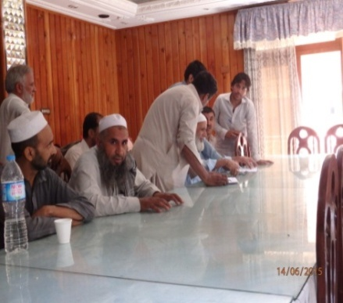
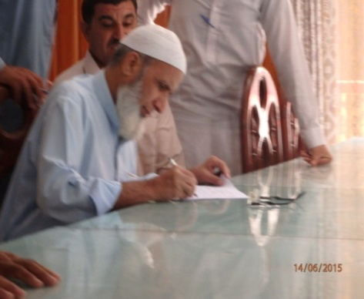
Activity Title: Peer to Peer meeting
Date: 16-06-2015
Venue: SPDA sub Office Faqir Abad Street no 4 Hussain house Peshawar city
( mid in the city , Convenient of all Participants )
Objectives:
- Discussed the basic needs and Daily living Activities for PWDs
- Discussed the recreational opportunities for PWDs
Achievements:
- The facilitator told them that there should be sports environment at home for the children by the parents.
- The facilitator gave good solutions to mothers how to give their children full care and dealing in daily activities.
- The facilitator told to the parents about the awareness about the LCWDs problems on priority no one.
- The facilitator explained that always should have positive interest for the children basic issues.
- The facilitator told them that always trust and rely on their own support and not depend on others help and support.
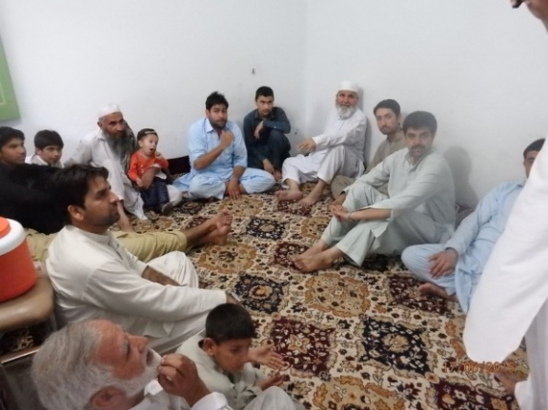
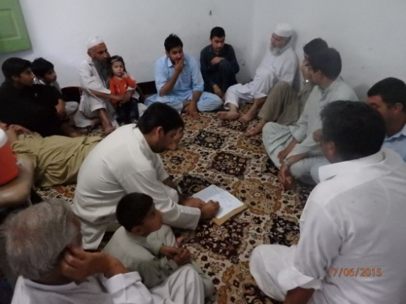
The facilitator also stressed that every Parents should have awareness about their children basic needs.

Activity Title: Distribution of Ramadan Food package
Date: 24-06-2015
Venue: Amir Shadi (Wedding) Hall Gulbahar Peshawar
Objectives:
- To support the vulnerable community by providing Ramadan package
Achievements:
110 food packages were distributed among the PWDs, widows, orphans, and other vulnerable community. This was full food package for 1 month to average family (5-7) persons. The package was donated by Ummah welfare Trust Pakistan. From 2013 every year Ummah welfare Trust provide the Package and SDPA is providing the distribution facility. SPDA has provided some food packages on the PWDs home, the entire Beneficiary has appreciated the activity and thanked to Ummah and SDPA.
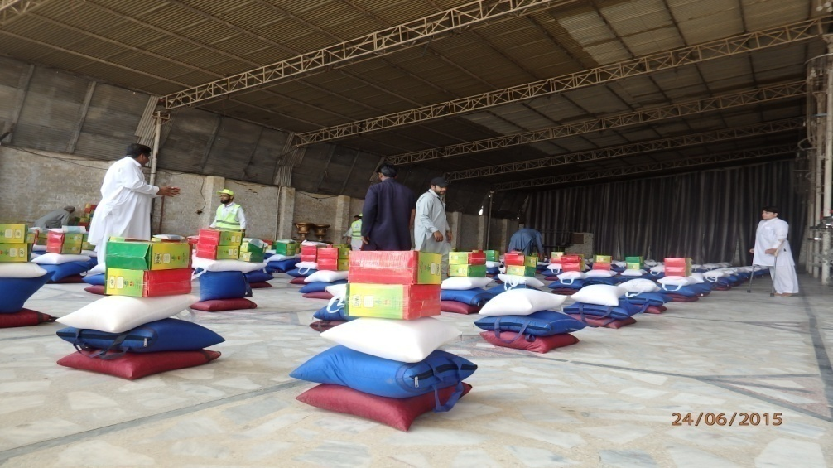
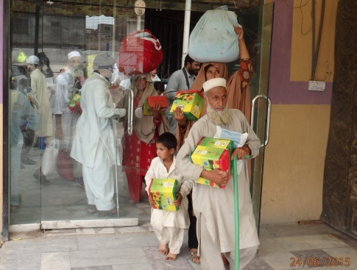

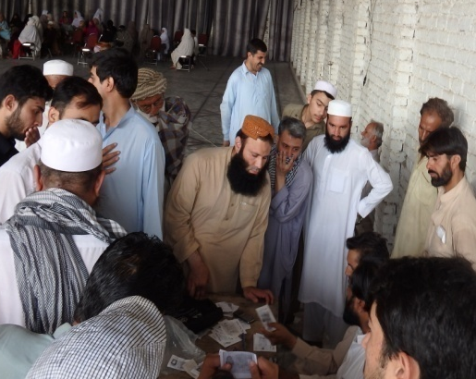
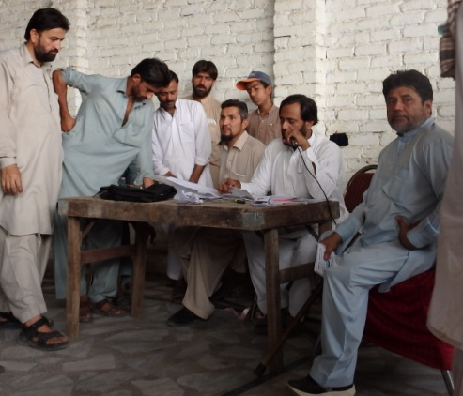
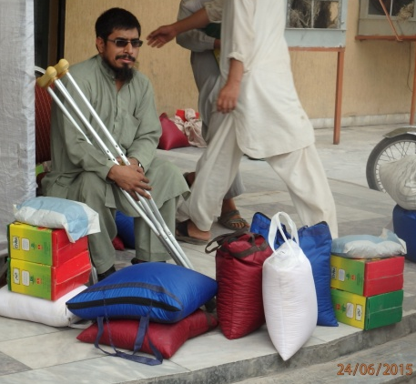

Activity Title: Peer support meeting
Date: 30-07-2015
Venue: Ummara khan (Peer group father’s Hujra) Peshawar cantt.
Objectives:
- To discussed the problems face by Parents
- to get financial aid from the Govt of KPK
- To gave information the parents about the KPK disability bill and new legislation for rehabilitation of PWDs.
Achievements:
- The facilitator told parents that they should try to provide a recreational environment at home to the children.
- The facilitator pointed out that previous govt had less interest to disabled children but present provincial govt is bringing disability bill for disabled persons and children to provide basic needs and requirements in the society.
So all the participants were satisfied during the discussion

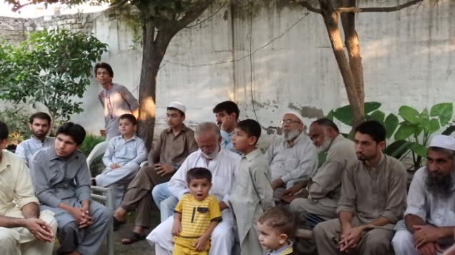
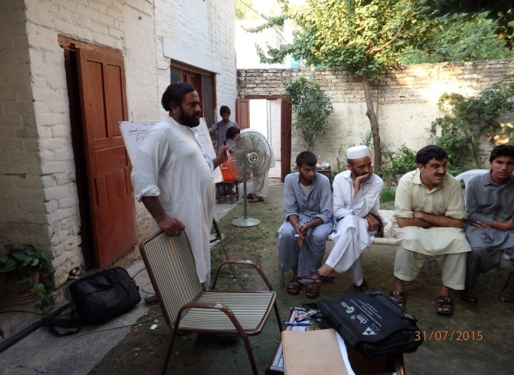

Activity Title: One day session on Disability Awareness
Date: 01-08-2015
Venue: Peshawar Medical College Warsak road Peshawar
Objectives:
- To sensitize the medical professionals and other relevant peoples about disability issues.
- To provide opportunity of Inclusion for PWDs in society.

Achievements:
Parents of PWDs, members of DPOs and medical professionals have aware from the disability issues, gave them orientation about accessibility and Inclusion of PWDs. The session was very informative and all the participants have appreciated the activity.
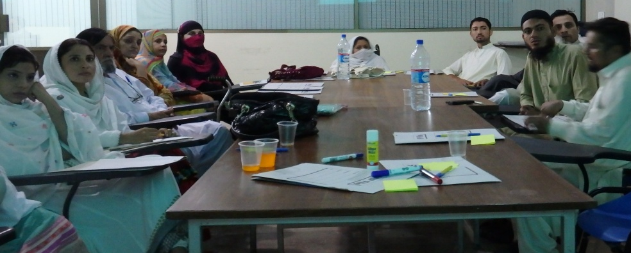
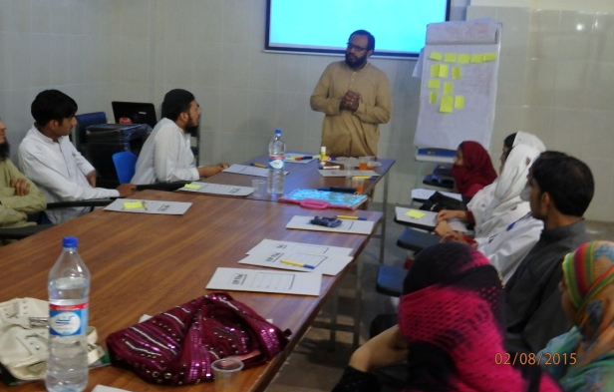

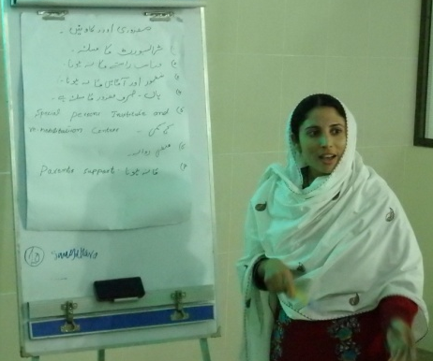
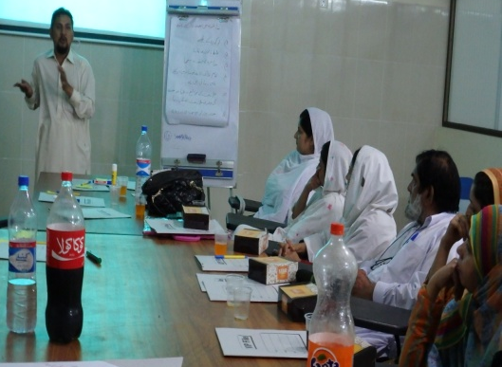
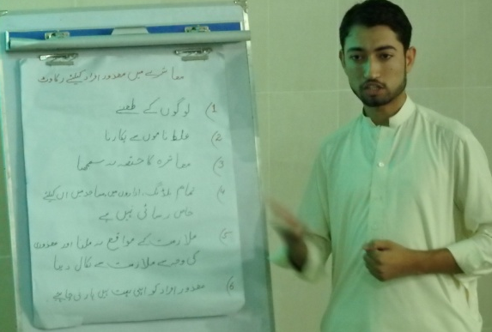

Activity Title: Peer support meeting, Focus Group Discussion
Date: 28-08-2015
Venue: SPDA sub Office fakir Abad Street no 4 Husain house Peshawar city
( mid in the city , Convenience for all Participants )
Objectives:
- To find out the practical solution of the Problem, after closing MHC.
- To plan the recreation tour
Achievements:
- The facilitator told them that there less centres for the LCWDs but parents can arrange some support on their end at home for the children.
- The facilitator told parents that always depend on your support to your children at home but less support on other
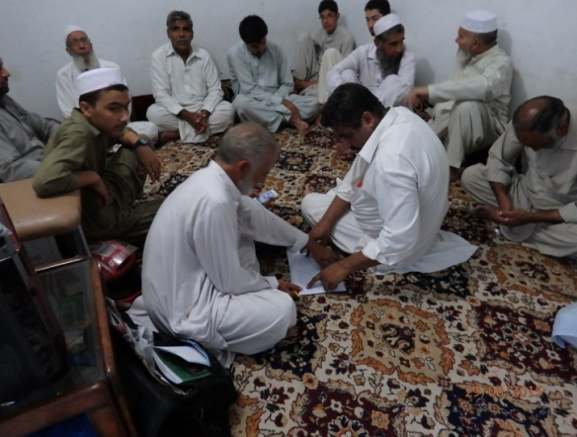
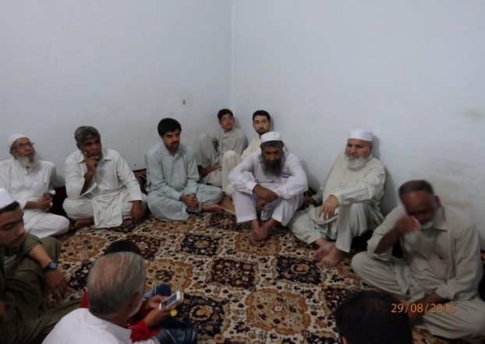

Activity Title: Consultative work shop on New Disability bill of KPK

Date: 31^{st August} and 1st September-2015

Venue: Pearl Continental Hotel Peshawar

Objectives:
- To gave inputs in the new disability bill as representative of PWDs
- To give suggestion for the practical inclusion on legislation Level and other sector of life

Achievements:
Activity Title: Recreational Tour
Date: 13-09-2015
Venue: Islamabad
Objectives:
- To Provide Recreational opportunities to LCWDs.
- To Involve LCWDs in productive and positive activities (Playing sports competition).
- To educate the parents how they can involve their children in some positive and Recreational activities.
- To give some suggestion and Practical demonstration to the Parents how they can deal their children by involving some physical and sports activities.
- To Provide Outside home visiting opportunities to LCWDs and their parents.

Achievements:
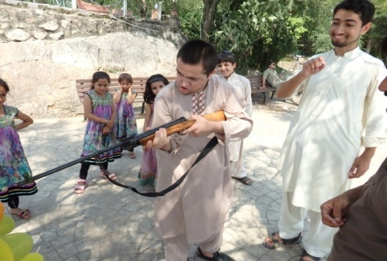
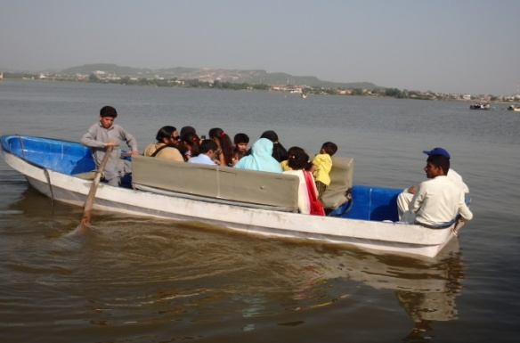
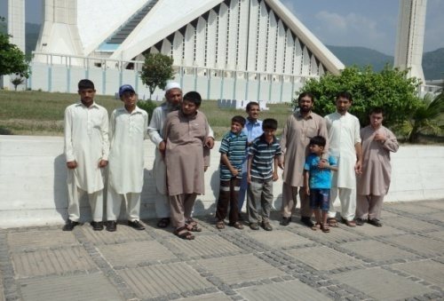
Parents have decreased their stress as well as they gain knowledge of a lot that we can involve our kids in some recreational activities

Activity Title: Distribution ceremony of Eid gifts among Poor, orphan and disabled children
Date: 23-09-2015
Venue: SPDA main office Bakhshu Pul Peshawar
Objectives:
- To provide Eid Gifts to the Deserving children’s
- To support CWDs on Eid occasion to enjoy their Eid by getting New Clothes and shows

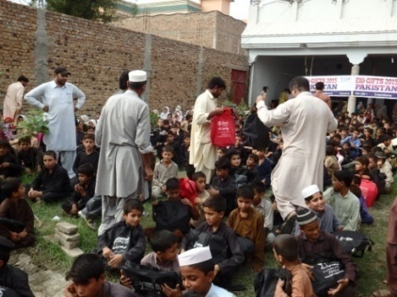
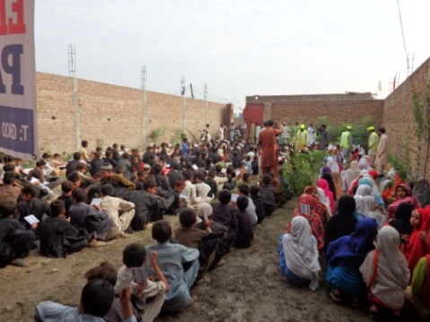
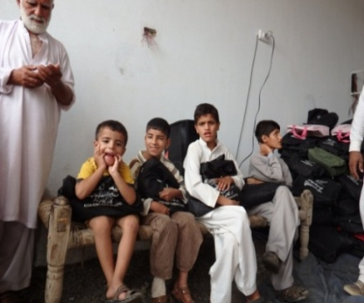
Achievements: SPDA organized Eid gift Package for 500 poor, orphan and disabled children of the Muslim Abad village. This EID package was provided by UMMAH Welfare Trust. The package was contained on clothes and shoes for 5 to 12 years age children. The package was also received by three children and one brother of SPDA and CBM Project for LCWDs (learning children with disabilities). The names of the children were M.ismail, M.Ibrahim, Jawad Ahmad and his brother. Besides these children, the package was distributed among 400 poor children of Muslim Abad Peshawar. The SPDA organizers were general secretary, Ihsanuulah, President Mahazullah, Project Officer Rashid Muhammad and finance Secretary Javed khan. There were SPDA volunteers, Sabirullah, Haroon khan and zarshad Ali who were involved in the ceremony. The package was distributed among children by Ummah welfare trust organizers and SPDA members. SPDA always appreciates and promote such activities for disabled and poor children and hope in future that Ummah welfare trust will conduct such activities.

Activity Title: Peer meeting
Date: 29-09-2015
Venue: SPDA sub Office fakir Abad Street no 4 Husain house Peshawar city
( mid in the city , Convenience for all Participants )

Objectives:
- To discussed over all problem and share information
- Meeting with CBM advisor in Islam Abad

Achievements:
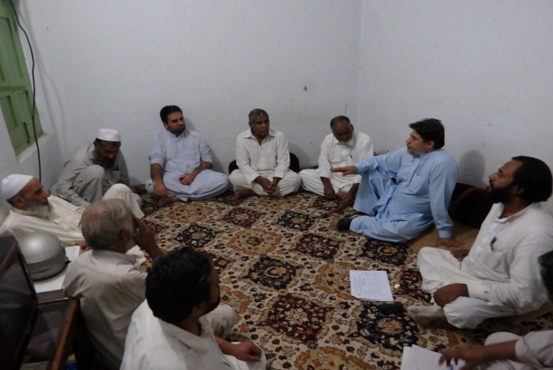
All the parents were informed about the Islam Abad meeting they were showed interest in the coming activities SPDA president Mr, Mahaz ullah has discussed all the project activities and took feedback about the SPDA services all the parents were gave very positive feedback about all the activities
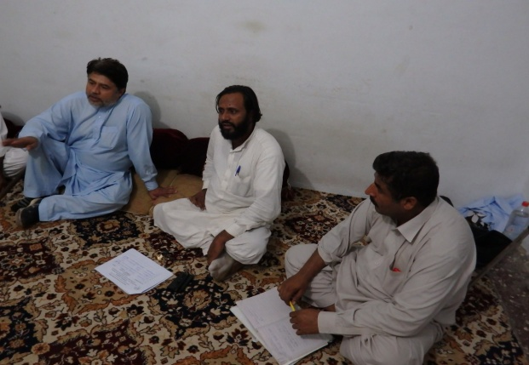

Activity Title: Disability Equality Training (DET)
Date: 07-11-2015
Venue: Govt blind School GT road Peshawar
Objectives:
- To reach a social model of Disability as Opposed to an Individual ,charity or medical model of Disability
- To develop Plan of action with the consultation of PWDs, through which the participants in the training can make changes in their working environment and make inclusive for the PWDs.
Achievements:
Summary of the Activity / meeting:
On day training on “Disability Equality” organized by SPDA (Special Person Development Association) with the collaboration of U.S education foundation Pakistan (U.S embassy). On 7th November 2015 SPDA (Special Person Development Association) has organized one day training on “Disability Equality “
There were about 30 persons including Male and Female Teachers, Persons with disabilities and their parents, Local Govt. Officials and project staff have participated in this training
After this the questionnaire about disability equality has been given to the participant in order to find views of the participants regarding disability. Most of the participants were unable to define disability. The questioner been given to the participants has been collected. The first session has started on disability by Ihsan Ullah Daudzai. He asked the question from the participants that what you know about disability.
After discussion on disability definition according to the UN convention, after detailed discussion he told that disability is not in any individual but it depends upon the environment in which the persons with disabilities are living.
The 2nd session has started by Ihsan Ullah Daudzai about accessibility. The trainer defined accessibility with examples .He described that accessibility means easy to reach, easy to enter, easy to move and easy to use, Ihsan has described the importance of accessibility for the persons with disabilities.
After the 2nd session there was a group activity. The participants were divided in three different groups and tasks were assigned to them.
After group work the group leaders has presented the problems faced by visual impaired, physical and speech and hear impaired persons. They have also presented the solutions of the problems been arises in the group activity.The Training was very much appreciated by all the Participants
Some of the participants gave their Feedback on the session that this the first time that we realised that Disability is nothing but its different style of life, attention of the Participants during all the session was remarkable
All the SPDA Staff was thanked to the Participants
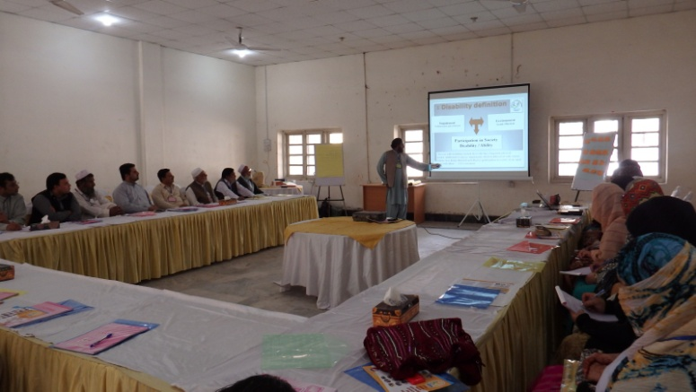
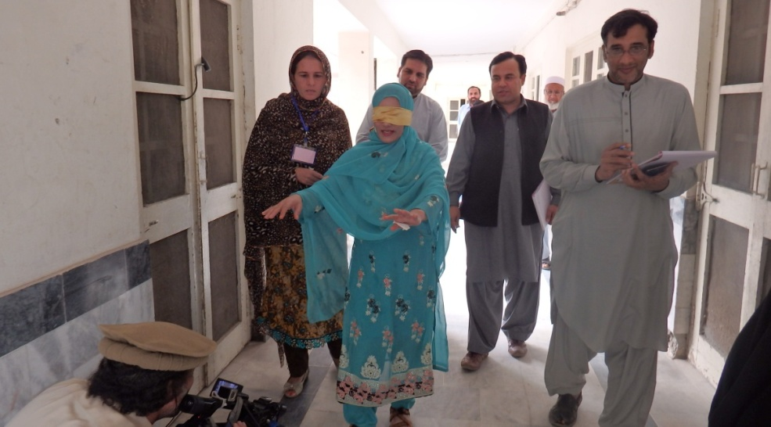

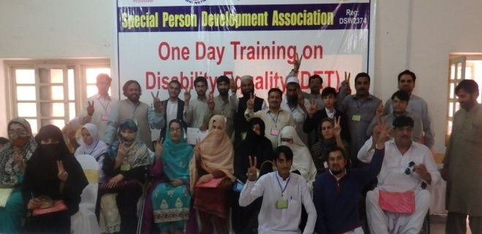

Activity Title: Training on child safeguarding
Date: 10th -13th 2015
Venue: Margala Hotel Islamabad
Objectives:
- To understand child safeguard
- Make action plan for the organization on child protection issue
- To understand child abuse, minimized the risk of abusing
- To provide a child safe environment among the org.

Achievements:
Gen, Secretary and Project officer of SPDA was attended the meeting and learn a lot from this training and SPDA has making for child safeguard policy for SPDA
Activity Title: Disability Equality Training (DET)
Date: 15-11-2015
Venue: Govt blind School GT road Peshawar
Objectives:
- To reach a social model of Disability as Opposed to an Individual ,charity or medical model of Disability
- To develop Plan of action with the consultation of PWDs, through which the participants in the training can make changes in their working environment and make inclusive for the PWDs.
Achievements:
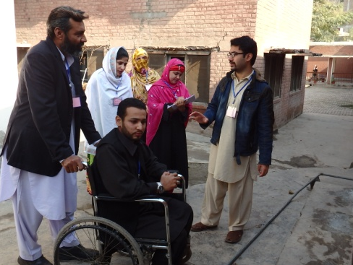
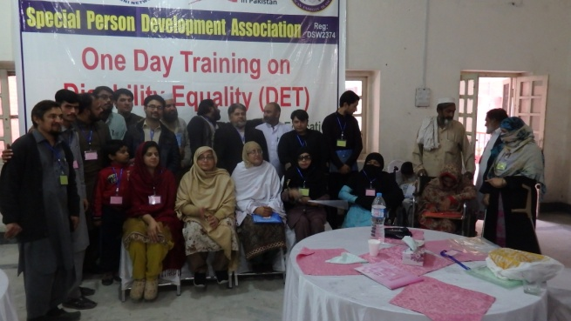
In a practical manner the participants were educated about disability, All the participants were understand disability, they realized it’s a basic human rights issue, the action plan were made for the positive changes in the community.

Activity Title: Celebration of International Day of Persons with Disabilities
Date: 03rd December 2015
Venue: Perl Continental Hotel Peshawar
Objectives:
- To celebrate the International Day of Persons with Disabilities and make awareness in the society.
Achievements:
SPDA has made the collaboration with Urat Foundation and Pakistan association of the Blind more than 150 Participants were attended the seminar. Media officials, member of provincial assembly, and many PWDs were participated
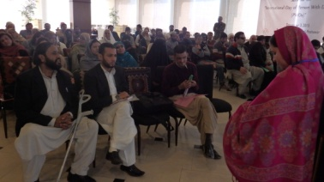
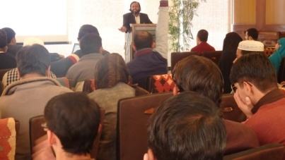

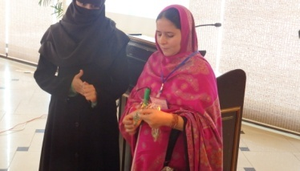
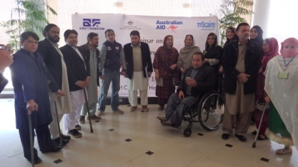

Report Prepared By: Ihsan ullah Daudzai, Javed Khan,Sabir ullah
Presented to: Executive board of SPDA

