Annual General Report of SPDA (Special Persons Development Association)
(January to December 2014)

Special Persons Development Association (Reg) Peshawar KPK Pakistan
Ihsan ullah,Javed Khan,Sabir ullah

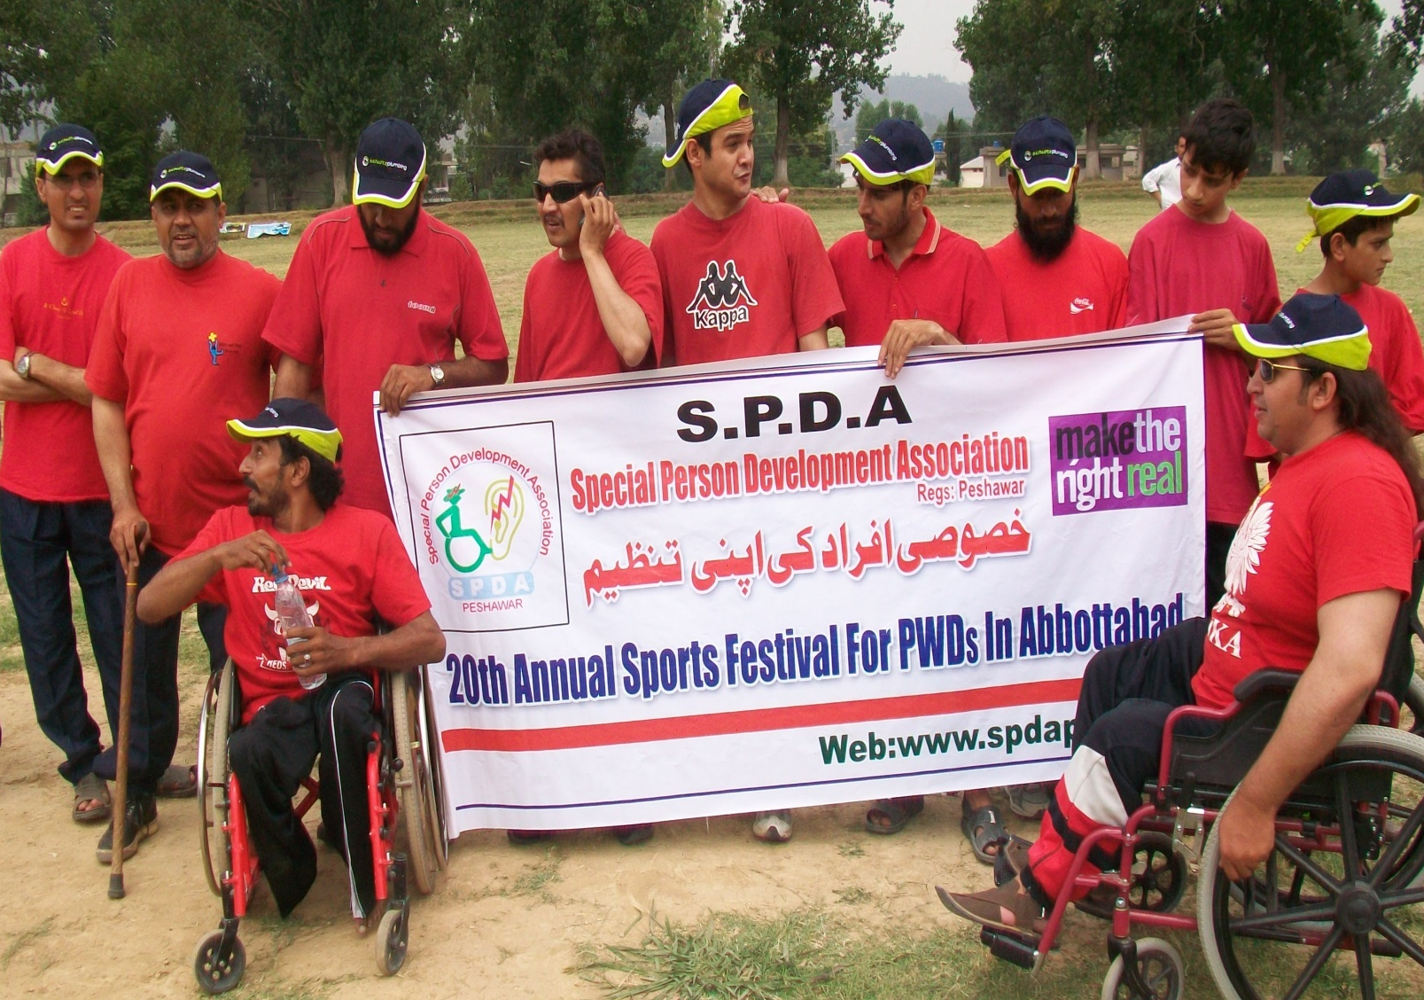
Activity Title: Fathers (Parents) Meeting of LCWDs

Date: 4th January 2014 (Starting Time 10:10 am Ending Time 12:15 pm)
Venue: SPDA office Bakhshu pul Peshawar.
Objectives:
- To aware the parents about the coming activities of CBM and SPDA.
- To gave them detail Introduction of SPDA
- Benefits and importance of disability certificate
- To aware them How to make disability certificate for their CWDs.
Achievements:
All the parents of learning children with disabilities were agreed and realized the importance of Disability certificate.
Activity Title: Mothers (Parents) Meeting Report of Learning CWDs
Date: 11th January 2014 (Starting Time 10:30 am Ending Time 12:10 pm)
Venue: Naheed Tara home (Hussain House Zeryab colony Peshawar city) .
- Objectives: To aware the parents about the coming activities of CBM and SPDA.
- To gave them detail Introduction of SPDA
- Benefits and importance of disability certificate
- To aware them How to make disability certificate for their CWDs.
Achievements:
All the mothers of learning children with disabilities were agreed and realized the importance of Disability certificate.

Activity Title: Disability awareness session for officials and members of Sayad Foundation Jewar Mardan
Date: 15th November 2014
Venue: Govt Girls Middle School village Jewar Mardan
Objectives:
- To show the real picture of disability instead of charity model support
- To aware the PWDs about its basic rights
- To give motivation to PWDs to start the straggle for their own rights
Achievements:
All the participants of the session they were very much motivated and they were aware from their basic rights, they were guided how registered their organization and how they can become a part of the disability rights movement in Pakistan.
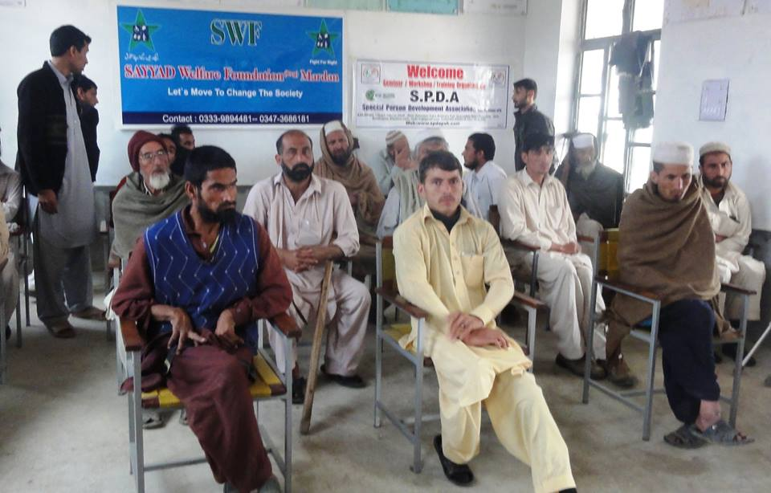
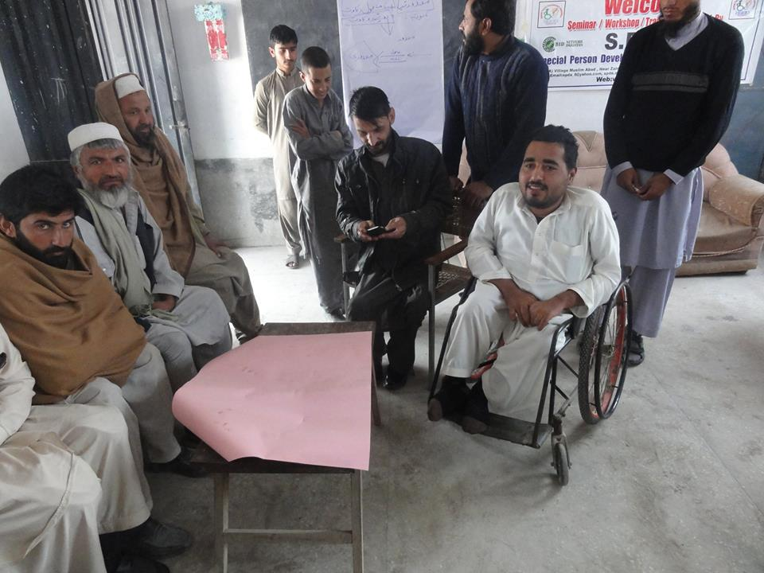

Activity Title: Sensitization session about 3rd December “International day of person with disabilities” for media officials at Press club Peshawar
Date: 30th November 2014
Venue: Peshawar Press Club Peshawar.
Objectives:
- To sensitize the media officials about the Importance of 3rd December “International day of person with disabilities”
- To high light the Issues faced by PWDs in society
Achievements: The Media Officials were sensitized about the problem and issues faced by PWDs in society.
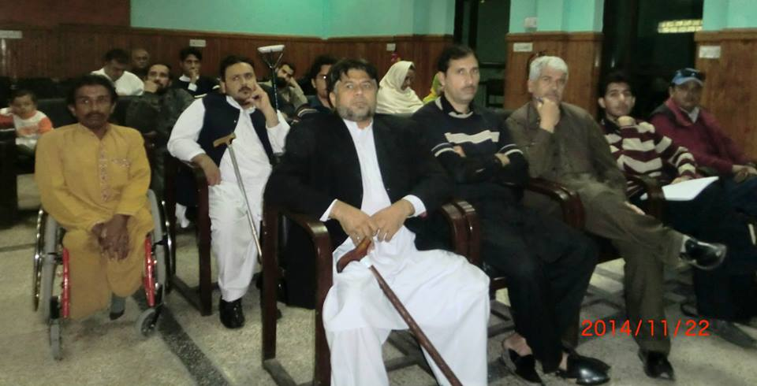
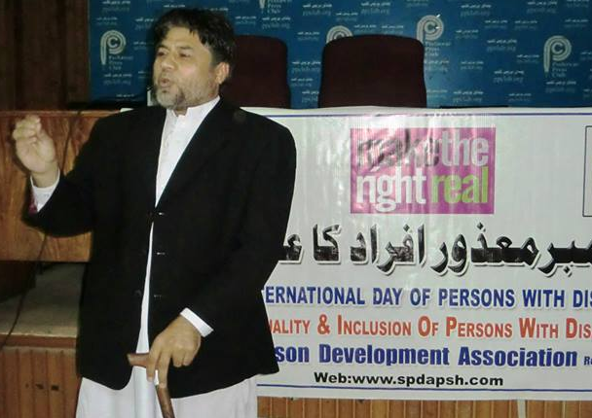
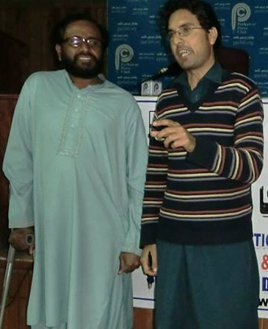
Activity Title: National Paralympics game 2014
Date:
Venue: Qayoom Sports stadium Peshawar
Objectives:
- To provide the game opportunities to PWDs
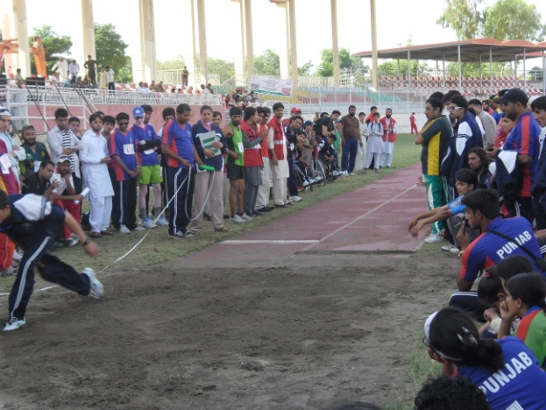
- To Include the PWDs in society by providing recreational opportunities

Achievements:
SPDA team has actively participated in all events and won some trophy

Activity Title: CBID National Conference 2014
Date:
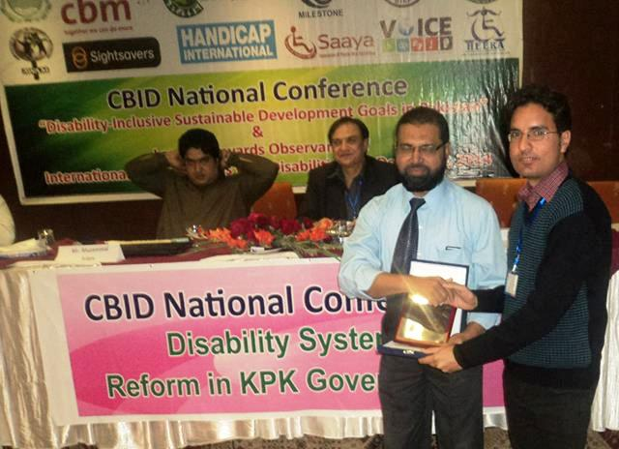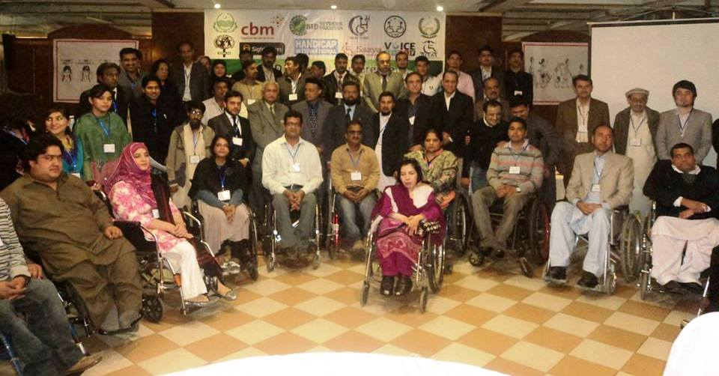
Venue: Hill view hotel Islam abad
Objectives:
- To unite the DPOs and make more effective the disability net work in Pakistan
Achievements:
2 members of SPDA has participated in the national conference, SPDA is an active member of CBID net work Pakistan
Activity Title: CBM Partner work shop
Date: 2nd to 5th June 2014
Venue: Istanbul Turkey
Objectives:
- Capacity development of the Partners of CBM
Achievements: President and General Secretary SPDA has participated in the work shop in this work shop the CBM build the capacity of SPDA regarding financial matters and as well as operational related issues

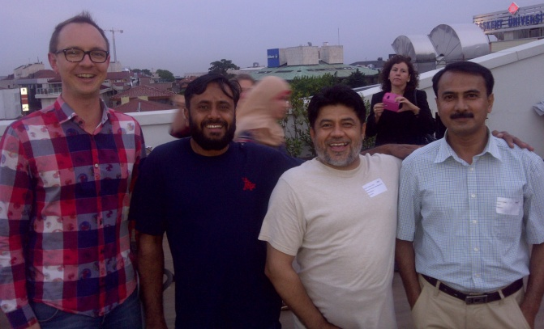
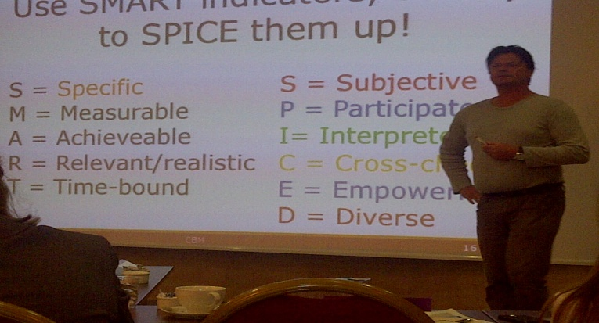

Activity Title: Abbot Abad Sport’s festival
Date: June 2014
Venue: Abbot abad city PCB ground
Objectives:
- To provide the game opportunities to PWDs
- To Include the PWDs in society by providing recreational opportunities
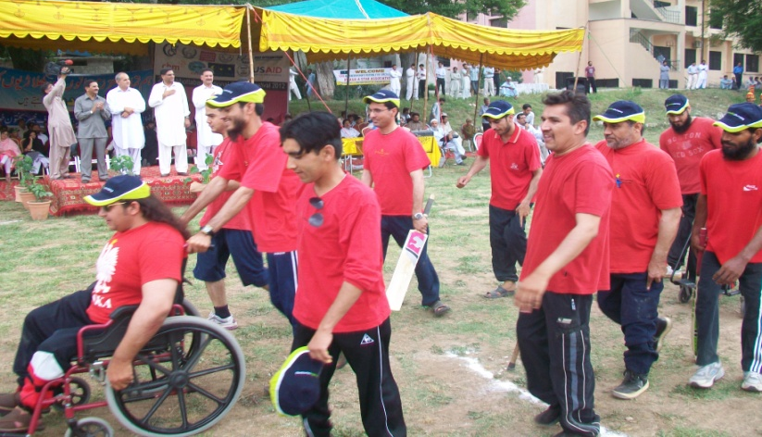
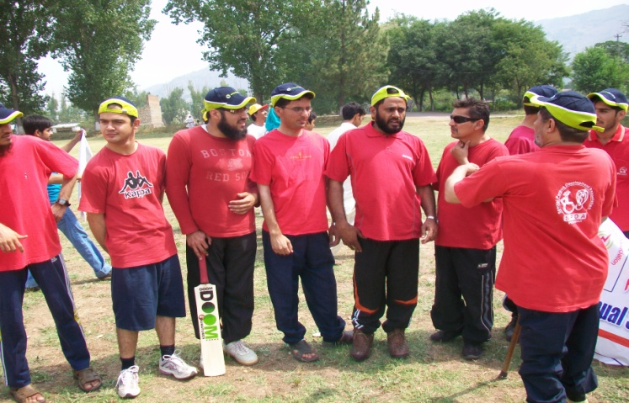

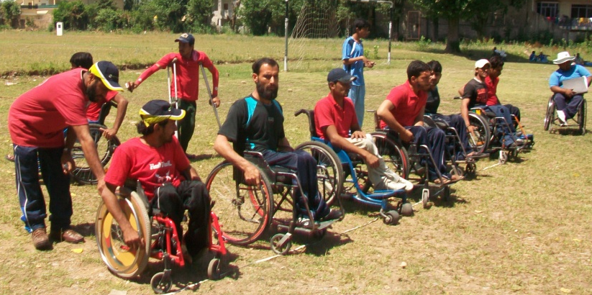
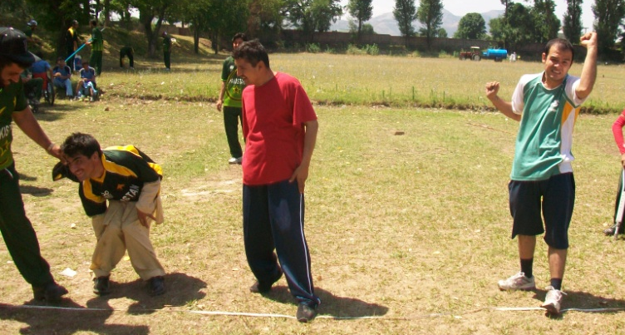

Achievements:
SPDA team has actively participated in all events and won some trophy

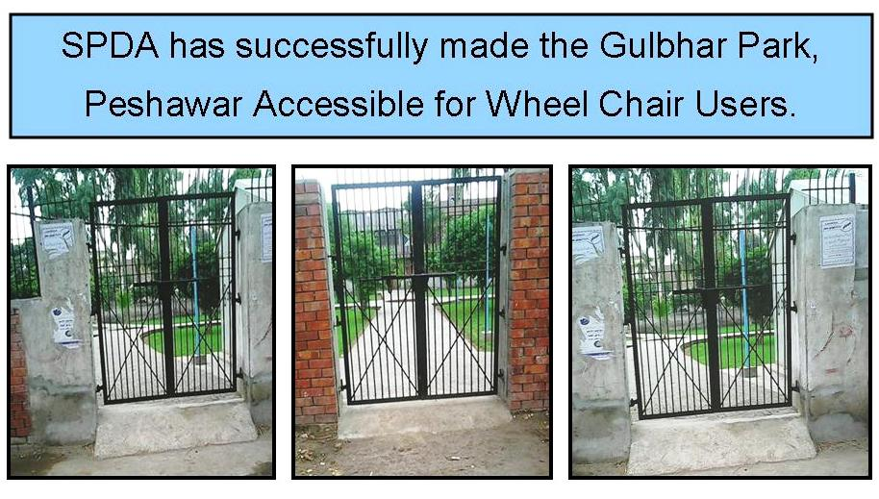
Activity Title: Practical work for accessibility

Activity Title: Celebration of International white cane day
Date: 15th October 2014
Venue: Peshawar press Club Peshawar
Objectives:
- To celebrate the International white cane day and sensitized the media for highlighting the issues of PWDs.
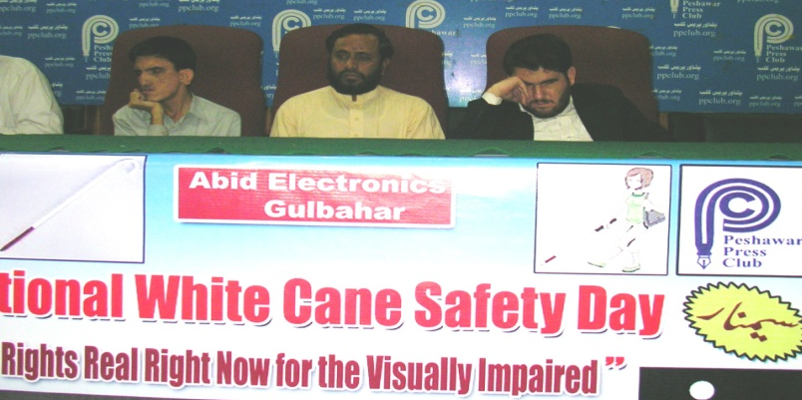
Achievements: The media officials were sensitized and they aware about the white cane day and issues of visually Impaired persons

Activity Title: Food Distribution (Umma welfare Trust and SPDA)
Date: July 2014
Venue: Amir shadi Hall gulbahar no 1 peshawar
Objectives:
- To provide support to PWDs and their family by providing food package during Ramadan
Achievements:
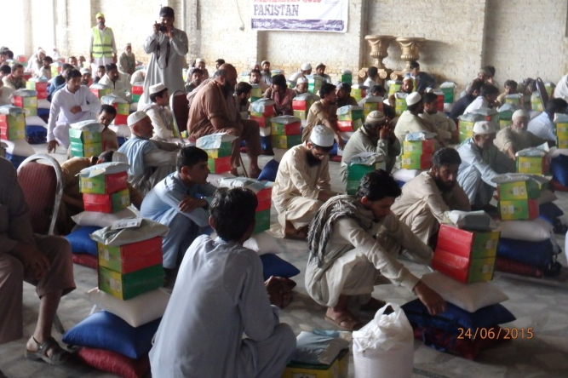
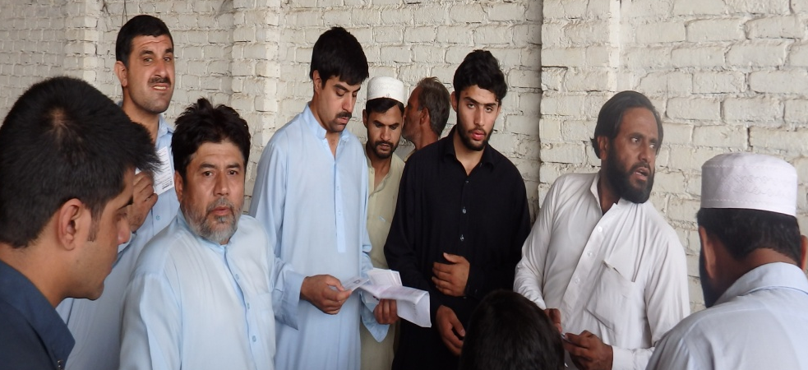
160 families of PWDs and other needy person received the food package during holy month of Ramadan
Activity Title: Celebration of World Disability day in collaboration
Date: 3rd December 2014
Venue: Nishtar Hall Peshawar.
Objectives:
- To celebrate the International Day of Persons with Disabilities and make awareness in the society.
Achievements:
Govt of Khyber pukhtoon khawa Media officials, member of provincial assembly, and many PWDs were participated
Activity Title: 4 days Accessibility Training organized by CBM
Date: December 2014
Venue: Islam abad (chief International Office)
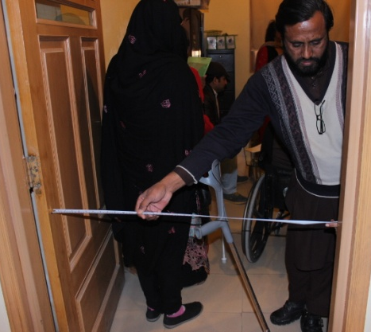
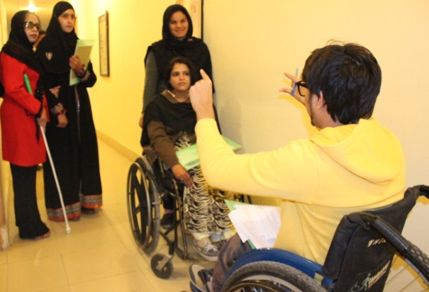
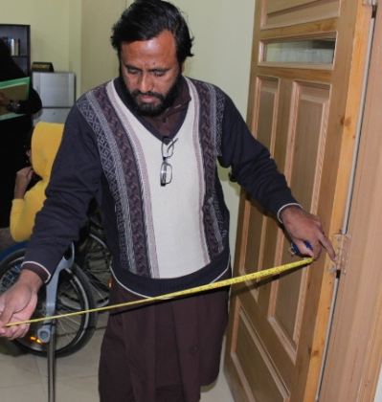

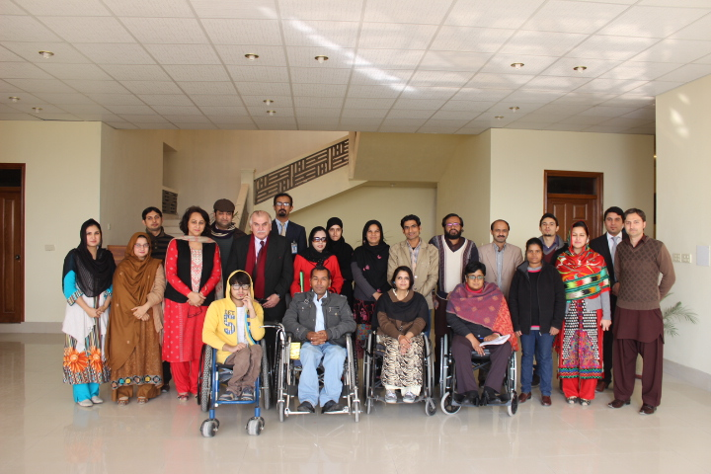

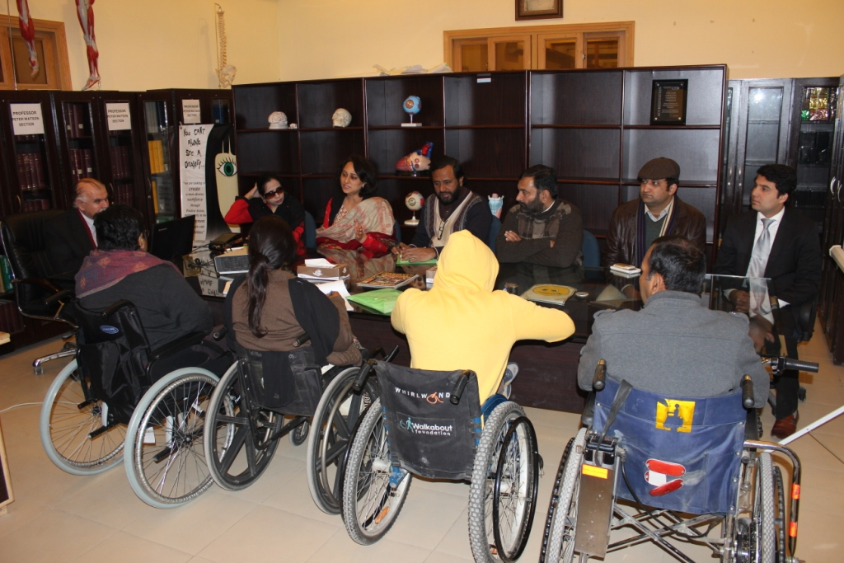

Objectives:
- To developed the capacity of partners regarding accessibility

Achievements:
2 members of SPDA has participated in the training and able to do accessibility audit, identified barriers and find the possible solution
Report Prepared By: Ihsan ullah Daudzai, Javed Khan,Sabir ullah
Presented to: Executive board of SPDA

